he Official Publication of ALOA—An International Association of Security Professionals

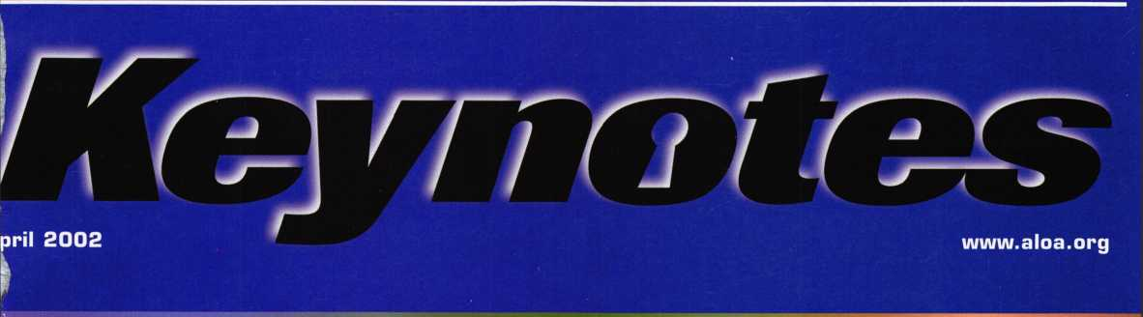

**NSTITUTIONAL**



cn

A Mosler Lug Door Safe, Shim Picking Techniques,  
New Tools, Re-Keying a Hotel, Phone Etiquette for  
Locksmiths and Much More



.

*m*

hi



Yale® and Yale Security Inc.® are registered trademarks of Yale Security Inc. SecureX™ is a trademark of Yale Security Inc.

Sure, old Spike here will do the job. But you're going to have to feed him and walk him. SecureX,™our new patent pending controlled exit device with delayed egress, will stop anyone in their tracks without taking a bite out of their backside. It's the kind of product you've come to expect from Yale, one of the most respected names in the industry. So you have a decision to make. Contact us at 888-828-8349, or visit our website at [www.yalelocks.com](http://www.yalelocks.com) to find out more. Or go buy 50 lbs. of dry dog food.

Delayed Egress Exit Device

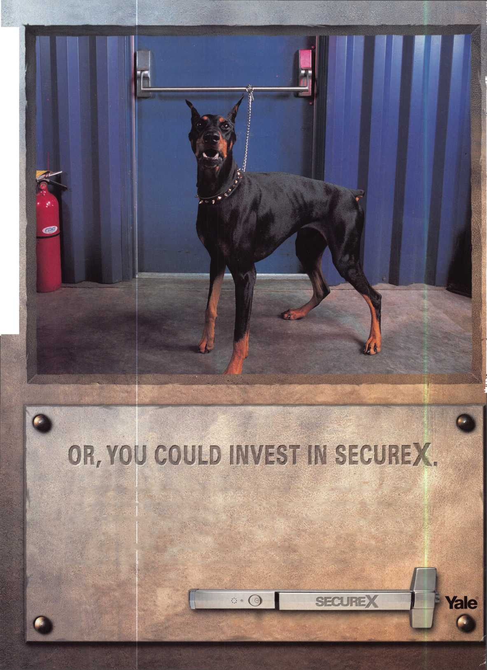

ick Up Some Players!

**tubers #\***

**For Chapters and Affiliates Who Recruit!**

If your chapter gets 15 new members: ALOA will send instructors out to your site for two free days of ACE classes FREE OF CHARGE! Plus, the chap­ter or affiliate that recruits the most new members gets three free convention packages for our blowout show in sparkling Las Vegas in July of 2003!

Don't pass up this fantas­tic chance for these cnjhat free giveaways, an ™ expanded group of peers with whom to learn and grqw, and the same fantastic education, protection and promotion ALOA has been providing for our great profession for almost 50 years! Call us today at 800/532-ALOA (2562) for more informa-

Attention Current Members! As the best security pros in the world, you play a vital role in making ALOA what it is. You make our industry hgm, and we're going to prove it this year by offering you more benefits than ever. For the entire calendar year of 2002, those who , recruit new members will receive special gifts from ALOA. We're asking you to prove you're a pro by sup­porting the only professional organization that exists to help educate, protect and promote security profession­als in America and beyond. Here are some of the details of our campaign:

**AIUA locksmiths**

Secure America

**For New Members!**

All newly recruited members receive a useful ALOA 11-piece pick set from LAB, plus our stirring "ALOA Locksmiths Secure America" decal for the shop or van

**For Current Members Who Recruit!**

1 new member: The useful ALOA 11-piece pick set from LAB.

5 new members: A handsome ALOA Polo Shirt (w/ stitched logo)

10 new members: LAB's great Schlage/Kwikset Combination pin kit -- plus membership in the ALOA President's Club, with your choice of a dazzling ALOA ring or a classic ALOA blazer (plus a periodic listing in Keynotes).



r 1 1 i

tion, or visit us on the web at [www.aloa.org](http://www.aloa.org).

#»*ew

**ALOA Membership. Prove You're a Pro**

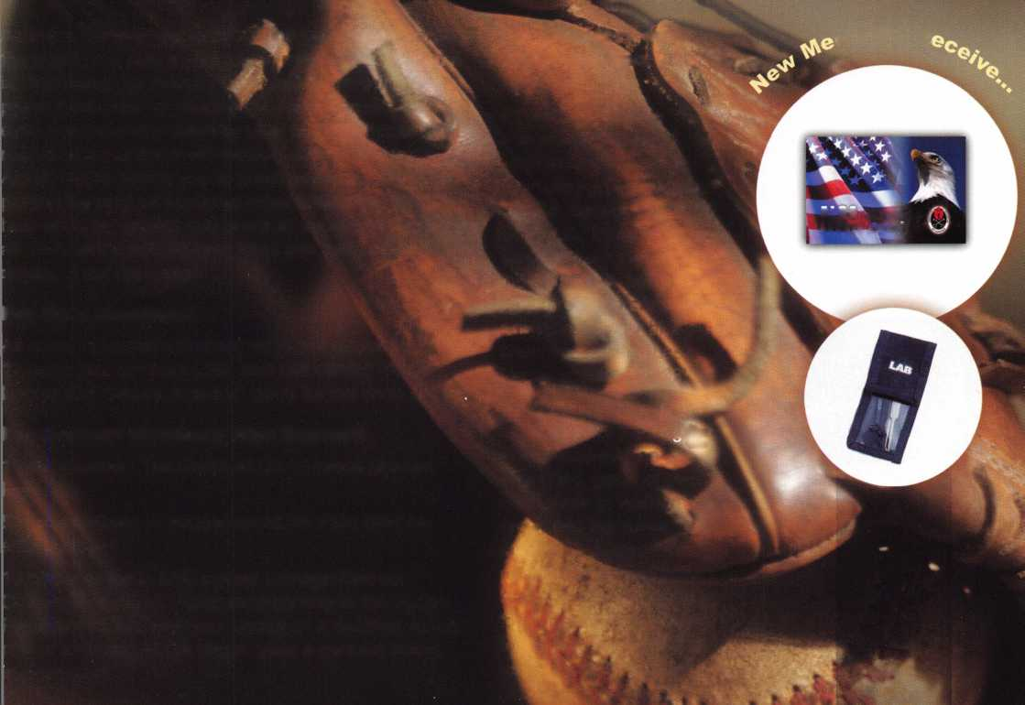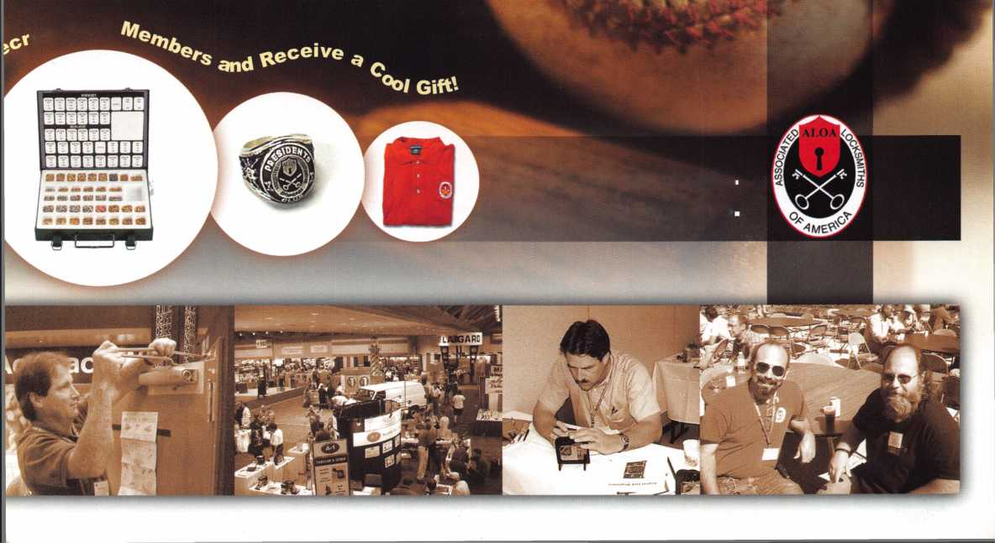

**features**

|  |  |
| --- | --- |
| r  d | epartments |
| 4 | President's Journey |
| 6 | Applicants |
| 8 | Upcoming Events |
| 10 | Core |
| 38 | Legislative Update |
| 40 | Classifieds |
| 42 | Associate Member Listing |
| 44 | Back Page |
| L | j |

COVER: Institutional Locksmithing

12

Fixing the Feds:

Channing Tucker

Stays Smart as a Federal Employee By John Roos

In a California office of the General Services Administration,

there is a locksmithing guru who believes that old-fashioned val­ues like education and hard work still lead to success.



Shim Picking Techniques

and Variations By Sal Dulcamaro, GAL

With a little bit of knowledge and practice, it is rarely a difficult task for the typical locksmith to shim pick most common pin tum­bler cylinders in order to remove the cylinder plugs for removal and service. Here's how.



New Tools

by Don Dennis, CPL

Locksmiths and their tools make a complete package. One with­out the other would be inconceivable. This year's offering of fas­cinating tools not only gave excitement but also boosted the skill level of those participating in the offerings.



The Big Hotel Re-Key By Greg Perry, GAL, CPS

That big hotel in town has asked for a rekey bid. You've eyed this account for a quite a while. The competition has been servic­ing them but this time you underbid them and have the job to master key all the rooms. Seems straightforward enough. Until you see a problem with the master key.



Another Opportunity:

Mosler Lug Door Safe By Greg Perry, CML,CPS

It started with a phone call from a friend regarding the lug door. Could I open the lug door tomorrow morning? The answer of course was, yes!



The Voice at the End

of the Phone Line bxchireCohen, cml

We need to question if we have the right person(s) handling the telephones for our business. This is the person who is the initial contact with our existing and potential customers. Sometimes we seriously consider whom we place as the "voice" at the end of the phone line. Most of the time, it's much more than that.

Visit

our we

b s i t e at

[www.aloa.org](http://www.aloa.org)

Keynotes • April 2002

executive



Additional contact information for the ALOA Board and most Keynotes authors is available through "Locksmith Search'" on the ALOA Web site- [www.aloa.org](http://www.aloa.org) or by contacting the ALOA office at 3003 Live Oak Street; Dallas, TX 75204; (800)532-2562; FAX (214)827-1810; e-mail [aloa@aloa.org](mailto:aloa@aloa.org).

Editor

Jim DeSimone [editor@aloa.org](mailto:editor@aloa.org)

Technical Editor

David Lowell, CML, CMST [david@aloa.org](mailto:david@aloa.org)

Editorial Advisor

John D. Cannon, CML [jdcannon@worldnet.att.net](mailto:jdcannon@worldnet.att.net)

Art Director

Betty Henderson [betty@aloa.org](mailto:betty@aloa.org)

Advertising Sales e-mail: [adsales@aloa.org](mailto:adsales@aloa.org)

Executive Director

Charles W. Gibson, Jr., CAE [charlie@aloa.org](mailto:charlie@aloa.org)

Convention & Meetings Manager

Kelly Carr, CMP [kelly@aloa.org](mailto:kelly@aloa.org)

PRP/Education Manager

David Lowell, CML, CMST [david@aloa.org](mailto:david@aloa.org)

Operations/Membership Manager

Mary May [mary@aloa.org](mailto:mary@aloa.org)

Director of Information Technology

Randy McChristian [randy@aloa.org](mailto:randy@aloa.org)

Government Affairs Manager/

Chapters & Regional Associations Liaison

Tim McMullen [tim@aloa.org](mailto:tim@aloa.org)

Comptroller Kathy J. Romo

Network Specialist Greg Jackson

Membership Coordinator Shelly Jett

Convention & Meetings Assistant Karen Lyons PRP/Education Coordinator Ashley Manson

Accounting Coordinator Kathy Stokes

Mail Room Coordinator Dennis Henderson

Contributors

Jerome Andrews, CML Paul Chandler, CRL Claire Cohen, CML Brian Costley, CML, CMST Ray D'Adamo, CML

Sal Dulcamaro, CML Billy Edwards, CML Dan Graffeo, CRL,CMST AJ. Hoffman, CML Jeff Nunberg, CML, CMST

Mike Oehlert, CPL, CPS Randy Simpson, CML Robert Stafford, CML Dave Thielen, CML Greg Perry, CML,CPS

Tom Seroogy Charles Stephenson, CPS Dennis Watanabe, CML, CMST

Mission Statement: The Associated Locksmiths of America, Inc. is dedicated to enhancing the professionalism, education and ethics among locksmiths and those in related sectors of the physical security industry. With approximately 10,000 members in the United States, Canada and the freeworld, ALOA is poised to help members obtain the knowledge, the strength, and the confidence to perform their role in the physical security field with pride and dignity. But it is only through active involvement and participation that ALOA can fully achieve its potential—and can help members to achieve theirs.

Policies: Keynotes® is the official publication of the Associated Locksmiths of America, Inc. (ALOA). Keynotes® acts as a moderator without approving, disapproving, or guaranteeing the validity or accuracy of any data, claim, or opinion appearing under a byline or obtained or quoted from an acknowl­edged source. The opinions expressed by the authors do not necessarily reflect the official views of ALOA. Also, appearance of advertisements and new products or service information does not constitute an endorsement of products or services featured by the Association. The Association does not accept responsibility for the inaccuracy of any data, claim, or opinion appearing in this publication, due to typographical errors on the part of the authors, Association staff or its agents.

Editor's Note: This publication is designed to provide accurate and authoritative information in regard to the subject matter covered. It is provided and disseminated with the understanding that the publisher is not engaged in rendering legal or other professional services. If legal advice and other expert assistance is required, the services of a competent professional should be sought.

Authors' Payment: Payment for eligible submissions to Keynotes will be based on the following criteria: topic, time spent and past contributions. Authors who regularly submit to Keynotes® are generally paid a higher rate. The latter is especially true of authors who write to fit specific editorial needs and submit said copy by Keynotes® deadlines. As a general guideline: Average payment for a 750 word, business or light' technical article would be $200. Payment for a 1500 word article involving significantly higher time and research efforts would be $400.

Payment will not be offered for articles submitted by ALOA employees or members of the ALOA Board of Directors (unless material is of a technical nature), nor for articles submitted by a company that promote that company's products or services. ALOA reserves the right not to pay for articles sub­mitted by an individual(s) that promote a particular company's products or services.

Disclaimer: The Associated Locksmiths of America, Inc., (ALOA), reserves the right to refuse any article for any reason. Additionally, ALOA reserves the right to edit, amend or modify any article submitted for publication in order to preserve technical accuracy, clarity, fairness or grammatical cor­rectness. ALOA will make the best efforts to notify the author of any changes. The extent of ALOA's liability for any article or information contained therein will be a notice of correction or retraction in the next possible issue.

Keynotes® (ISSN 0277 0792) is published monthly except for the combined June/July issue by The Associated Locksmiths of America, Inc., 3003 Live Oak St., Dallas, TX 75204-6186. Telephone: (214) 827-1701; FAX (214) 827-1810; e-mail [aloa@aloa.org](mailto:aloa@aloa.org). Subscription rates for members—$15.00 per year. Second class postage paid at Dallas, Texas. POSTMASTER: Send address changes to: Keynotes, 3003 Live Oak St., Dallas, TX 75204-6186. © Copyright 1999, All rights reserved. No part of the contents may be reproduced or reprinted in any form without prior written permission of the publisher.

President

Randy Simpson, CML  
(713) 780-7026

[president@aloa.org](mailto:president@aloa.org)

Secretary

John D. Cannon, CML  
(703) 960-6413  
[secretary@aloa.org](mailto:secretary@aloa.org)

Directors, Northeast

John C. Magee, III  
(856) 845-3434  
nedirector@aloa .org

Peter Sarailian, CRL  
(201) 947-6291  
[nedirector@aloa.org](mailto:nedirector@aloa.org)

William L. Young, CML  
(610) 647-5042  
[nedirector@aloa.org](mailto:nedirector@aloa.org)

Directors, Southeast

Vincent Formon, CML, CPS  
(901) 324-2910  
[sedirector@aloa.org](mailto:sedirector@aloa.org)

Donald E. Rule, CML  
(662) 324-2658  
[sedirector@aloa.org](mailto:sedirector@aloa.org)

Directors, North Central

Mark E. Blum, CML, CPS  
(517)482-5809  
[ncdirector@aloa.org](mailto:ncdirector@aloa.org)

John Soderland, CML, CMST  
(414) 327-5625  
[ncdirector@aloa.org](mailto:ncdirector@aloa.org)

Director, South Central

Randy L. Simpson, CML

1. 780-7026 president@aloa. org

Directors, Southwest

Gordon R. Racine, CML  
(719) 384-4707  
swdirector@aloa .org

Julie McCluney, CRL

1. 636-5652 swd i rector@a loa. org

Director, Northwest

Scott L. Henke, CRL, CPS  
(907) 248-3785  
nwdirector@aloa. org

Director, Associate Members

David F. Mafthies  
(727) 541-5536

[asdirector@aloa.org](mailto:asdirector@aloa.org)

Trustees

John J. Greenan, CML, CPS  
(773) 486.2030

Dallas Brooks  
(334) 826-8990

David M. Lowell, CML, CMST  
(800) 532-2562

Edwin Toepfer, RL

Past Presidents

1999-2001 John Greenan, CML, CPS  
1997-1999 Dallas C. Brooks  
1995-1997 David Lowell, CML, CMST  
1993-1995 Breck Camp, CML  
1991-1993 Henry Printz, CML  
1989-1991 Evelyn Wersonick, CML, CPS  
1987-1989 Leonard Passarello, CPL  
1985-1987 Joe Jackman, CMl  
1983-1985 Stanley Haney, CPL  
1981-1983 Louis LaGreco, CPL  
1979-1981 John Kerr, RL  
1977-1979 Clifford Cox, CML  
1974-1977 Charles Hetherington  
1972-1974 Gene laughridge  
1970-1972 William Dutcher, RL  
1968-1970 Constant Maffey, RL  
1966-1968 Harold Edelstein, RL  
1964-1966 William Meacham  
1962-1964 Robert Rackliffe, CPL  
1960-1962 Edwin Toepfer, RL  
1956-1960 Ernest Johannesen

Keynotes • April 2002



president's

journey

Hello Members,

Who cares? What are we doing? When will it happen? Where will we go? How are we  
going to do it?

This year, for the first time since ALOA's first election in 1956 (one year before I was born),  
our members from the Asian region and European region will elect their own voting direc-  
tors. This international group comprises more than 10 percent of our members. Our board  
will now reflect a true opinion of members from continents around the globe.

What does it mean for ALOA and its members?

What we are doing is similar to major corporations operating in a global environment.  
Our board will have new ideas based on different paradigms of business. We will find  
out that many European shops are certified. We may find out about words like ISO9001.  
Certification is much more important in Europe than in the states. Will that become a trend  
to the rest of the world? When will it happen? Like most things, change is slow in coming.  
But time eventually catches up. Today's companies were once only national. (How do you  
say "Starbucks" in German?) Just two global companies produce most of the world's lock  
hardware. From import to export give and take, that Schlage lockset is made of parts from  
around the world. Some of their product lines have 100 percent of the parts brought in  
from outside the United States only to be assembled and sold here.

Where we are going is to an international style of business. Consumers are better educated.  
They can compare products over the Internet. ALOA is working on our first Internet train-  
ing venture. Hopefully, within the near distant future, we can offer training to our members  
worldwide via the Internet.

How we will get there is still uncertain. We have a lot of information to consume and to  
incorporate into our organization. The goal is for our members to be the world leaders in

global security.

Randy Simpson, CML

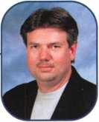

Keynotes • April 2002



THZEJ

***Visit our Website on  
www. stamcctv. com***

THE COMPLETE

CCTV PROGRAM ON CD-ROM  
FOR STAFF TRAINING AND  
PRODUCTIVITY ENHANCEMEN

STAM Insight has been  
developed to enhance CCTV  
skills and productivity with  
many different uses.

IP Productivity

* System Drawing
* Estimation

**#** CCTV Training  
**t#** CCTV Reference  
**I#** Sales/Demo

* System Design
* Staff Evaluation

**INFOMATE WORKMATE ULTIMATE**

*CCTV Content* CCTV Calculators Demonstration Tool

Knowledge Assessment

**Sold in Over 50 Countries**

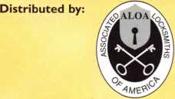

3003 Live Oak Street  
Dallas,Texas 75204

Name:

Job Title:

Organization: Address:

.Zip/Postcode, .e-mail

Fax: ( )

COPYRIGHT © 1996 Security Training and Marketing Pty Ltd. All rights reserved ACN 057 006 541

Country

Tel: ( )

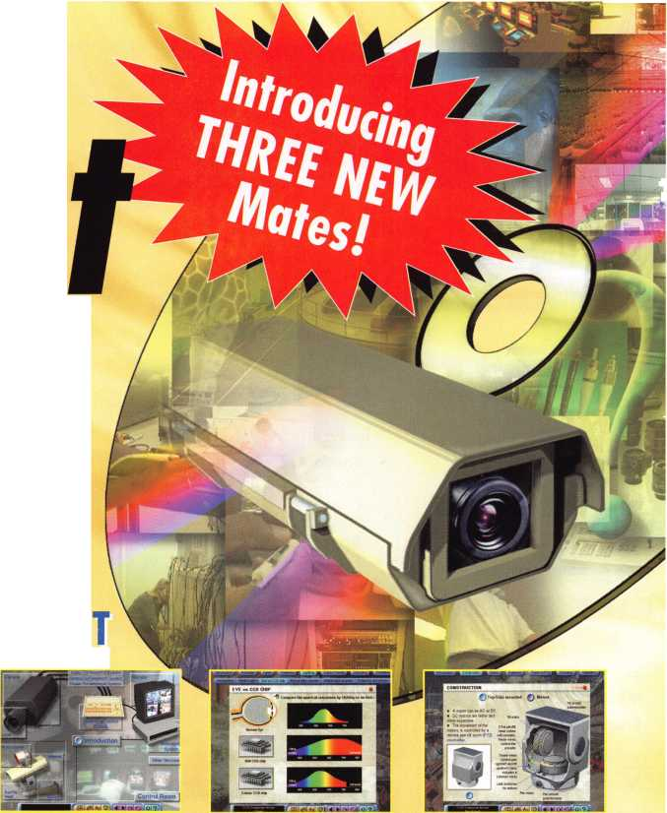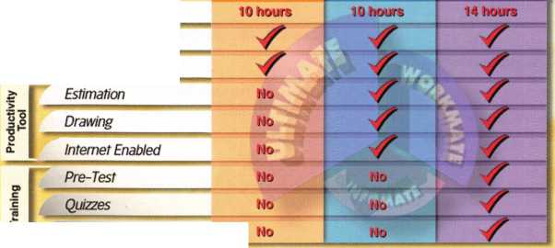

**Mesa**

Roger A. Mahnk Jr

Sponsor: John A. Ilk CRL, CPS

**Phoenix**

Khamryn Singh

Sponsor: William Lee

**Oak Creek**

Lee A. Schoeneman CML

**New Britain**

Tom Melkus Maura Griffin Brad Aylett

**Wethersfield**

Norma Sullivan

**Des Moines**

Mike Bromert

Sponsor: David M. Howdle

**Chicago**

George W. Raby

Sponsor: William T. Beranelc

**Westmont**

Dale Hayes

South Bend Jack W. Seifer

**Berryton**

Jason A. Crouch

Sponsor: Dana R. Hall

**Overland Park**

Royce L. Welch

Sponsor: Gregory N. Brandt CML

Shawnee Mission Michael Mangino

**Tecumseh**

Steve McCracken

**Topeka**

Lee Jackson

Sponsor: Dana R. Hall

Radcliff

Eli Murrell

Sponsor: Gerald W. Weldin CRL

**Baltimore**

Robert Rykaczewski

Sponsor: Robert D. DeWeese CML

**Easton**

Brian Lynch

Sponsor: Donald S. Remington

**Holland**

Brian J. Elwood

**Milan**

Mark Szentmiklosi

Sponsor: Thomas J. Lewis CPL

Portage

Ryan C. Aman

Sponsor: Terry L. Bussema CRL

Brainerd

Jerome D. Luke

Buffalo Lake

Corey Meyer

Aberdeen

Terry W. Lenoir

Sponsor: Marvin N. Rhoda CRL

Bozeman

Richard O'Donnell

**Asheville**

Allen Odom

**Candler**

Brian McFee

Lincolnton

Timothy M. O'Brien CRL

**Rocky Mount**

Karen Blount

**Mine Hill**

Jim Malcolm

Sponsor: Salvatore Scarpa III, CRL Wayne

John D'Alessandro

**Las Vegas**

John Falvey

Sponsor: Roger K. Bradford CRL

Aaron Anderson Michael Cote

Sponsor: Thomas J. Newton Jr, CML, CPS

**Brooklyn**

Jeff A. Simmons

Sponsor: Joel S. Kramer

**Constantia**

Timothy P. Conley

Sponsor: Robert Magnan

**New York**

Robert M. Mejia

These applicants are scheduled for clearance as members of ALOA. The names are published for member review and comment within 30  
days of this Keynotes issue date, respectively, to ensure applicants meet standards of ALOA's Code of Ethics. Protests, if any, should be  
addressed to the Membership Department and must be signed. Active Membership applicants (a) have worked in the industry two or more  
years. Allied Membership (AL) applicants are not locksmiths, but work in a security-related field. Apprentice Membership (AP) applicants

have worked in the industry less than two years.



Keynotes • April 2002

OK

Australia

Edmond

John J. Roth

PA

Abington

Gerry Holleran

Franklin

John Miller

Sponsor: George **C.** Blair

PR

San Juan

Guillermo Menendez Jr, AHC

TX

Abilene

Alan B. Wright

Keene

Kimilu Hammond

San Antonio

Thomas E. Fagan Jr

Sponsor: Clifford D. Lipscomb CML, CPS

Wl

Baraboo

Chet M. Leathers

Sponsor: William T. Beranek

Zetland

K M. Parker

England

Feltham Middlesex

Jason Dorner

Ireland

Dublin

Jason Coogan

Japan

Ako-City Hyogo

Kobayasi Masaki

Sponsor: Takashi Kuwana CRL

Nagoya-City Aichi

Satoru Tadokoro

Sponsor: Takashi Kuwana CRL

Sapporocity Hokkai

Taka Hayakawa

Sponsor: Takashi Kuwana CRL

Sendai-city Miyagi

Satoh Naoki

Sponsor: Takashi Kuwana CRL

Soujiya-city Okayam

Jiro Asano

Sponsor: Takashi Kuwana CRL

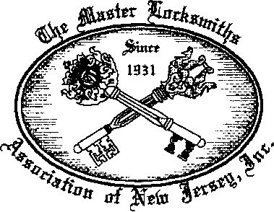

MLANJ 2002  
Annual Convention

April 18th thru April 21st  
Somerset, New Jersey

For More Information:

PO Box 2441

Morristown, NJ 0796272441  
Phone 973-627-6385  
Fax 973-627-3246

Or visit our web site at

**[www.MLANJ.orq](http://www.MLANJ.orq)**

Keynotes • April 2002

**APRIL ■ APRIL ■ APRIL ■ APRIL ■ APRIL**

U p

o m

n

9

Minnesota Chapter of ALOA Membership Meeting Broadway Pizza 2025 West River Road Minneapolis, MN

13-14

Folson, MT  
2 ACE Classes

Contact: Todd Rasmussen, CRL

(406) 883-2950

3-6

MLANJ Convention for 2003

Location TBA



Mount Diablo Chapter of CLA Meeting  
7pm • California Maritime Academy  
Vallejo, CA

Contact: Art Patch, CCL, CML

(707) 642-2661

13

PRP* SAFETECH 2002 • Reno NV Contact ALOA • (800)532-2562 or (214)827-SAFE (7233) [www.savta.org](http://www.savta.org) [convention@savta.org](mailto:convention@savta.org)

17

Central Florida Locksmith Association Membership Meeting 7;30pm 813 Montana St. • Orlando, FL Contact: Janet Boyer (386) 775-3641

Fox Valley Chapter of ALOA

Membership Meeting

Columbus Club

2531 N. Richmond St.

Appleton, Wl

Contact: Norm Zurawski,

CRL [lockeyone@lockeyone.com](mailto:lockeyone@lockeyone.com)

18-21

Master Locksmiths Association of New Jersey • Annual Convention April 17-21 • Garden State Convention Center and DoubleTree Hotel Somerset, NJ

Contact: Joseph LaVigne II, CRL 973/267-8884

18

Florida West Coast Locksmith

tion (FWCLA) • General Meeting  
(Detex w/Accent Marketing)

Temple Crest Civic Center  
512 Miller Ave. • Tampa FL

Contact: Rob Curry (727) 849-181

■I

8pm

20

PRP*20 ACE Classes and PRP Somerset, NJ Dan McGlynn, CML 973-267-8884 973-538-1588 [dfmcml@home.com](mailto:dfmcml@home.com) [www.mlanj.com](http://www.mlanj.com)

20

Greater Houston Locksmith

Automotive Class Auto Auction

Houston, TX

Contact: Ed Stites (979) 323J

or [ditels@fbtc.net](mailto:ditels@fbtc.net)

<http://ghla>. 1 cis.com/index.

27-28

California Locksmith Assn. Exec.

Committee Meeting • Ontario, CA

Contact: Norm Weisenberger

(818) 704-6197

Minnesota Chapter of ALO- Membership Meeting Broadway Pizza 2025 West River Road Minneapolis, MN

17

Central & Southern Colorado

Locksmith Assn • St. Joseph Church

1830 S. Corona Ave.,

Colorado Springs  
Contact: Barry Meyer, CRL

Greater Houston Locksmith Assn.

Basic Locksmithing with  
CD Lipscomb, CML, CPS

Rosenberg, TX • Contact: Ed Stites

(979) 323-9919 or [ditels@fbtc.net](mailto:ditels@fbtc.net)  
<http://ghla>. 1 cis.com/index.html

19

Central & Southern Colorado Locksmith Assn • St. Joseph Church 1830 S. Corona Ave., Colorado Springs Contact: Barry Meyer, CRL (303) 688-4104

19-20

ACE • Minnesota Chapter of ALOA 21st PRP Education weekend, Maplewood, Minnesota.

For more information:

Michael Mattern, CRL (952) 544-3399

19-21

April 19-21, 2002 Wyoming Locksmith Assn.

Annual Convention and Trade Show Days Inn • Casper Wyoming Contact: Gene Ficek, CPL (605) 642-4542

26-28

South Carolina Locksmith Assn. Meeting

Holiday Inn NE (1-20 & Two Notch Rd.) Columbia, SC Contact: Jean Griggs (803) 432-9008

**Don’t Miss**

**SAFETECH 2002**

APRIL 8-13

JOHN ASCUAGA'S NUGGET RESORT RENO, NEVADA • 1-800-443-1482

Central Florida Locksmith Association Membership Meeting 7:30pm 813 Montana St. • Orlando, FL Contact: Janet Boyer (386) 775-3641

16

Florida West Coast Locksmith Associa­tion (FWCLA) General Meeting 8pm (Don-Jo w/Buddy Brown SBS Assoc.) Temple Crest Civic Center 512 Miller • Tampa FL Rob Curry (727) 849-1812

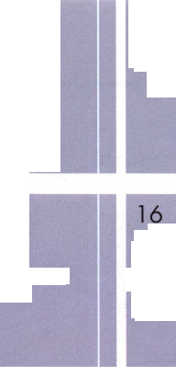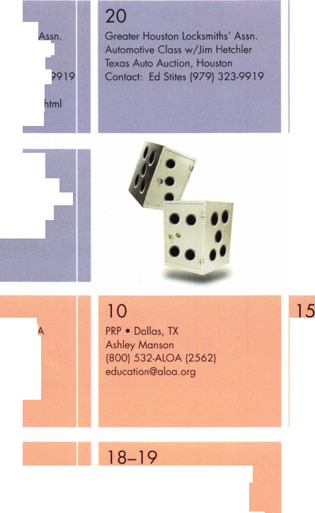

**OCTOBER I SEPT/OCT ■ AUGUST ■ JULY | JUNE ■ JUNE ■ JUNE**

event

s

|  |  |  |  |
| --- | --- | --- | --- |
| 1-2  Greater Houston Locksmith Assn. Intermediate Locksmithing with  CD Lipscomb, CML, CPS  Rosenberg, TX  Contact: Ed Stites (979) 323-9919  or [ditels@fbtc.net](mailto:ditels@fbtc.net)  <http://ghla>. 1 cis.com/index.html | 2  Greater Houston Locksmith Assn.  Swap Meet • 1 Oam - 4pm  Ft. Bend County Fairgrounds  Rosenberg, TX  <http://ghla>. 1 cis.com/index.html | 2  North Jersey Master  Locksmiths Association  8th Annual Flea Market  9a-2p • Quality Inn  Lyndhurst, NJ • Contact:  Nick Hart 201/944-7547 or  Jeff Sitar at 973/777-0620 | 14  PRP • Dallas, TX • Ashley Manson (800) 532-ALOA (2562) |

18

Mount Diablo Chapter of CLA Meeting 7pm • California Maritime Academy Vallejo, CA

Contact: Art Patch, CCL, CML (707) 642-2661

19

Central Florida Locksmith Association Membership Meeting 7:30pm 813 Montana St. • Orlando, FL Contact: Janet Boyer (386) 775-3641

20

Florida West Coast Locksmith Associa­tion (FWCLA) • General Meeting 8pm Temple Crest Civic Center 512 Miller Ave. • Tampa FL Contact: Rob Curry (727) 849-1812

21

Central & Southern Colorado Locksmith Assn • St. Joseph Church 1830 S. Corona Ave.,

Colorado Springs Contact: Barry Meyer, CRL (303) 688-4104

22-23

Greater Houston Locksmiths' Assn. Safe Penetration Party w/Dave McOmie

Clark Security Products • Houston, TX Contact: Ed Stites (979) 323-9919 or [ditels@fbtc.net](mailto:ditels@fbtc.net) <http://ghla>. 1 cis.com/index.html

21

Mount Diablo Chapter of CLA Meeting 7pm

California Maritime Academy Vallejo, CA

Contact: Art Patch, CCL, CML (707) 642-2661

**SEE PAGE 10 FOR A LISTING OF ACE/PRP CLASSES**

13-14

DHI Convention and Expo, Chicago, Illinois.

For more information: [www.dhi.org](http://www.dhi.org)

14-16

ISC EXPO/East Orlando, Florida For more information: siaonline.org

18

Florida West Coast Locksmith Association (FWCLA)

General Meeting 8pm (Steel Craft Doors w/Steve Puleo l/R) Temple Crest Civic Center 512 Miller Ave. • Tampa FL Contact: Rob Curry (727) 849-1812

19

Central & Southern Colorado Locksmith Assn St. Joseph Church 1830 S. Corona Ave., Colorado Springs Contact: Barry Meyer, CRL (303) 688-4104

22-28

ALOA 2002 Rosemont, IL Contact ALOA (800) 532-2562 [www.aloa.org](http://www.aloa.org) [convention@aloa.org](mailto:convention@aloa.org)

22-28

South Carolina Locksmith Assn. Meeting

Quality Inn (1000 Hearon Cir) Spartanburg, SC Contact: Jean Griggs (803) 432-9008

16

Central & Southern Colorado Locksmith Assn St. Joseph Church 1830 S. Corona Ave., Colorado Springs Contact: Barry Meyer, CRL (303) 688-4104

SEE PAGE 10 FOR A LISTING OF ACE/PRP CLASSES

14

Greater Houston Locksmith Assn. • Auto Opening with Steve Young

TBA • Contact: Ed Stites (979) 323-9919 or [ditels@fbtc.net](mailto:ditels@fbtc.net)

<http://ghla.lcis.com/index.htr>

19

Florida West Coast Locksmith Association (FWCLA)

General Meeting 8pm Temple Crest Civic Center 51 2 Miller Ave. • Tampa FL Contact: Rob Curry (727) 849-1812

25-29

SERLAC Trade Show - Orlando FL [www.serlac.com](http://www.serlac.com) Contact: Steve Blizzard (800) 845-529 ACE

27-29

Jo-Van Distributors Inc.

2002 Annual Security Show and Educational Conference Contact: Joan Daniels or Larry Malo at 416/752-2238 or 888/752-7210

Oct. 1-Oct. 5

Pacific Locksmith Association Annual Convention Holiday Inn-Portland Airport Contact: Karl Kretsch, CRL 541/741-6902 [www.pla-pro.org](http://www.pla-pro.org)

14-19

ACE Classes • Basic Locksmithing

Appleton, Wl • Fox Valley Technical

Jerry Antoon • 920-735-2406

920-735-2414

[antoon@foxvalleytech.com](mailto:antoon@foxvalleytech.com)

[www.fvtc.edu/SecurityCrimePrevention/](http://www.fvtc.edu/SecurityCrimePrevention/)

Locksmithing/lndex.htm

17

Florida West Coast Locksmith Associa­tion (FWCLA) • General Meeting 8pm Temple Crest Civic Center 512 Miller Ave. • Tampa FL Contact: Rob Curry (727) 849-1812

23-27

Greater Philadelphia Locksmiths Association • 2002 Convention, Radisson Hotel • Mt. Laurel, NJ Contact: Nelson Dayton 610/688-9188 or Ed Fitzgerald at 856/665-1311

25-27

South Carolina Locksmith Assn. Meeting 20th Anniversary Banquet & Installation of Officers and Board Holiday Inn NE (1-20 & Two Notch Rd.) Columbia, SC

Contact: Jean Griggs (803) 432-9008

- core

C.O.P.S. Discounts

SecuritySource.net(r) recently announced that it has entered into a strategic customer relations program with C.O.P.S. Monitoring, by which C.O.P.S/ dealer customers receive an automatic 2 percent discount on every security product pur­chase made through SecuritySource BuyDirect.

SecuritySource provides traditional distribution services to established dealers and systems integrators, and empowers them with a secure internet presence. From here, they can log on and select products from complete catalogs, receive individualized pricing and discounts, place orders, and even schedule and track deliveries any time, 24-hours a day.

For more information, visit their web site at [www.securi- tysource.net](http://www.securi-tysource.net)

Linking Cars with Homes

Turning on the lights and unlocking the front door of your home could be as easy as pushing a button in your vehicle.

At the recent North American International Auto Show in Detroit and the Consumer Electronics Show in Las Vegas, OnStar Corp., General Motors' high-tech communications subsidiary, unveiled details about an OnStar at Home pilot project.

Starting in February, 100 homeowners in southeastern Michigan tested technology that gave them control over lights and other parts of their home from their vehicle, personal computer or cell phone. They also were able to check the status of their homes, such as whether they locked the front door.

The technology was developed by the Internet Home Alliance, a group that includes OnStar, Invensys Control Systems, Panasonic, Hewlett-Packard and ADT Security Services Inc. The test will last four months.

Chet Huber, OnStar's president, said the pilot program will help the alliance determine the feasibility of producing such a system and whether it would appeal to a lot of consumers.

"This is not a dancing hologram that would come to the market in a different form in the future," he said. "We think we have something here that can be used in a meaningful way to connect the home and the vehicle."

Copyright 2002 Toronto Star Newspapers, Ltd.

Need Help?

At ALOA, we want to make sure you are getting as much bang for your membership dues buck as we are able to give you. If you have had problems getting membership services, or have a question regarding member services, please con­tact Bill Gibson, exectuve director, at 800/532-2562, or e-mail: [charlie@aloa.org](mailto:charlie@aloa.org).

New Certifications

CPLs

Matthew Eggleton

CRLs

Michael Dunkerly  
Robyn Lamb  
Bernard Mitchell III  
Tim Moline  
Allen Ragan  
Harold Summers

Current PRP

CMLs

CPLs

RL & CRL

CMST

CPS

Lenoir, NC

Plano, TX Alexandria, VA Stockbridge, GA Lewiston, MT Gadsden, AL Severn, MD

Totals

693 630 2727 11 176

Upcoming PRP Classes

April 7

Pacific Locksmith Association Portland, OR Karl Kretsch 541/979-5045

April 12

ALOA • Dallas, TX Ashley Manson 800/532-2562, ext. 30

April 14

Ohio Valley Chapter of ALOA Fairborn, OH William Lockwood, CRL 937/775-2154

April 20

Master Locksmith's Association of  
New Jersey Somerset, NJ  
Dan McGlyn  
973/367-8884

April 20

Minnesota Chapter of ALOA  
Maplewood, MN  
Michael Mattern  
952/544-3399

August 9

ALOA • Dallas, TX  
Contact: Ashley Manson  
800/532-2562, ext. 30

Upcoming ACE Classes

April 20

Master Locksmith's Association of  
New Jersey Somerset, NJ  
Dan McGlyn  
973/367-8884

April 27

Central NY Locksmith Assn.

1. ACE Class

Contact: Ronald Smith, CRL  
315/658-2368

June 29-30

Northern Indiana Chapter of  
ALOA

1. ACE Classes

Jermey Rodocker, CPL, CPS 219/459-1500

August 23-25

Central NY Locksmith Association k 2 ACE Classes Contact: Ronald Smith, CRL 315/658-2368

Sept. 21-22

Central NY Locksmith Association 1 ACE Class Ronald Smith, CRL 315/658-2368

JQ Keynotes • April 2002

Economic Stimulus Bill

**Signed Into Law - March 9, 2002**

"Job Creation and Worker Assistance Act of 2002"

(H.R. 3090)

ALOA-Supported Tax Provisions

On March 9, 2002, President Bush signed economic stimulus legislation that includes many of  
the key provisions to aid the security industry. As President Bush stated at the bill-signing ceremo-  
ny, "This measure will mean more job opportunities for workers in every part of our country,  
especially in manufacturing." The bill received overwhelming bi-partisan support in both the  
House and Senate with 417-3 and 85-9 votes respectively.

HIGHLIGHTS OF THE LEGISLATION

Bonus Depreciation: Creates bonus first-year depreciation of 30 percent over  
the next 3 years for new, qualified capital investments made after Sept. 1 1,

2001, and before Sept. 10, 2004, these investments include security and  
life safety equipment.

Extension of the Net Operating Loss (NOL) Carry-back  
Period: to 5 years (from 2 years) for NOLs arising in taxable years  
ending in 2001 and 2002.

Corporate AMT Relief:

* The new, temporary first-year bonus depreciation deduction is avail-  
  able for both regular and corporate AMT payers. Additionally, there

would be no adjustment to the allowable amount of depreciation for purpos-  
es of computing a taxpayer's alternative minimum taxable income with respect  
to property to which the provision applies.

* Two-year suspension of the AMT Net Operation Loss (NOL) 90 percent limitation for  
  NOLs arising in taxable years ending in 2001 and 2002. The change in the NOL  
  carry-back period to 5 years will benefit AMT payers as well.

Pension Reform: 30-year Treasury Note Interest Rate Fix applicable to defined benefit pension plans and PBGC variable rate premiums. Effective through 12/31/03.

Active Financing Income: Subpart F Exemption: seamless, retroactive extension of deferral for active financ­ing income for five years, effective from 1/1/02 through 12/31/06.

Details of stimulus bill may be found at: <http://www.house.gov/jct/x-12-02.pdf>

Keynotes • April 2002



Pinned to the partition of a federal employee’s office

in Southern California is the statement: “Some

it ain’t broke, don’t fix it.’ The govern-

says, ‘If it ain’t broke, fix it until

it is.’”

OK, very funny Glad to see the Feds can

poke fun at themselves. Still, Charming

Tucker, an Estimator/Planner for the

General Services Administration (GSA)

in Santa Ana, Calif, has spent  
the better part of 30 years  
turning that stereotypical  
notion on its ear.

You see, Tucker—a lanky, deep-  
voiced, roll-up-your-sleeves kind

of guy— believes that old-fashioned  
values like education and hard work will

lead to success. And he takes pride in his  
craft, enough to be held accountable for an  
honest day’s work. Perhaps most importantly, this

Los Angeles native continues to take on new challenges as advancements in

technology demand new and more sophisticated skills.

**12**

Keynotes • April 2002

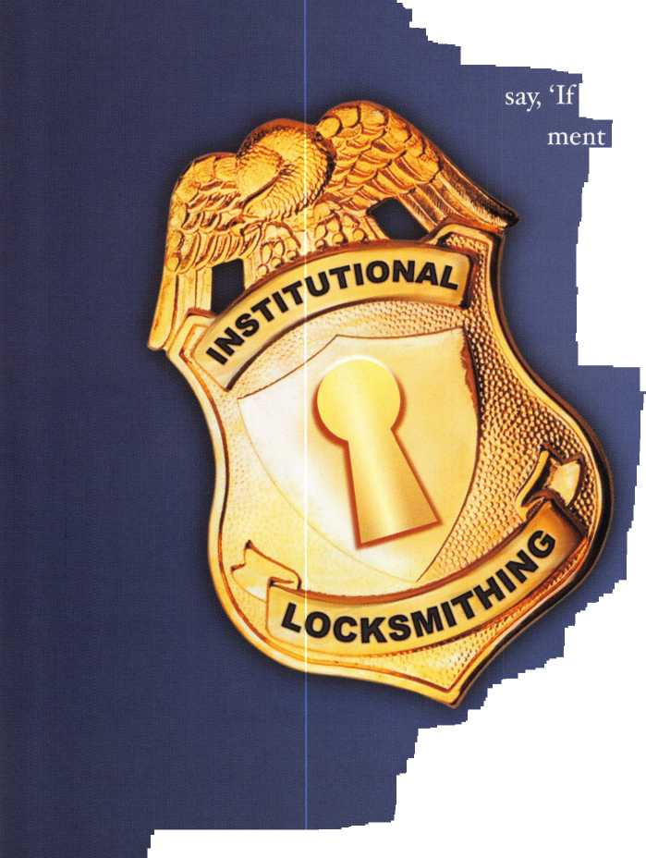

Make no mistake, Tucker—who resides in Garden Grove with his second wife, Carole-

is big on self-improvement through continuing education. For instance, he just last week com­pleted NFPA ioi, the National Fire Prevention Association’s training course on safety standards, which provides updates on uniform codes that regulate corridors and doors sizes; what types of locks can and cannot and be used; and situations where locks cannot be used at all, etc.

‘As technology grows, we need to learn more about the systems, how they function, and what some of the downfalls might be,” said Tucker during a recent interview. “One federal agency just experienced problems with the key cards they were originally issued in Laguna Niguel. Turns out they were not, as requested, multi-system compatible. So while we may not need to know all of the intricacies of how a card key interacts with integrated circuits in a computer system, it behooves us all to have a good understanding of how locks function.”

The 6i-year-old Tucker also reads a variety of trade publications (“Locksmith Ledger,”

“The National Locksmith,” and, of course, “Keynotes.”) in addition to networking with other institutional security professionals for camaraderie and to stay sharp.



By John Roos

“Fve found networking through associations to be invaluable,” he added. “Because we’re all working in the institutional (or industrial) arena, we have no problem sharing information and our knowledge. We want to help each other succeed... there isn’t that competition that you find with street locksmiths in the open market arena.”

While Tucker now enthusiastically talks shop, using familiar words like Schlage, tumblers, and magspots, his early passion was electronics. He remembers as a kid always “experimenting, building, tinkering, testing, and working on just about anything.”

“I was very lucky while attending junior high in the Los Angeles area because at that time, we rotated from one craft shop to the next,” he said. “I had wood shop, metal shop, print shop, auto shop... so I really had a chance to make things, or at least see how they work. By the time I took, and fell in love with, electrical shop in high school, I really knew I had the ability to be successful at it.”

Tucker parlayed this passion into income, first with the lighted sign business following gradua­tion from high school. After marrying his first wife in 1965, Tucker worked for about four years

Keynotes • April 2002

**13**

doing electronics instrumentation work for McDonnell Douglass Astronautics in Huntington Beach. Only lay-offs at that location left him unemployed, leading to a temporary-appointment as an electrician at the El Toro Marine Base.

Then Tucker received a pivotal phone call from the Civil Service Commission to interview for a similar job at the U.S. Coast Guard Station in San Clemente.

“I couldn’t figure out why a small facility like that would need an electrician,” Tucker recalls. “When I arrived for the interview, I was greeted by a Secret Service agent, and I remember saying to myself, ‘Oh, this must be President Nixon’s office building.’ And that was the start of my real Federal career.”

Indeed, it was 1971 and the Western White House office complex included three buildings constructed and operated by GSA, including a navigational transmitter site that happened to adjoin La Casa Pacifica, Nixon’s summer home.

At about the time Nixon resigned his Presidency, GSA-which was formed in 1949 to provide feder­al agencies with space acquisition, property man­agement, procurement, and security services— acquired the former Rockwell building in Laguna Niguel and transferred Tucker to what became Chet Holifield Federal Building. Tucker and his partner, Conrad Esser, were in charge of prepar­ing the building for incoming Federal tenants, such as IRS, INS, and the U.S. Geological Survey.

But a couple of years later when GSA decided they needed a locksmith for the just-opened Santa Ana Federal Building, they tapped a sur­prised Tucker.

**14**

Keynotes • April 2002

“One of the things we needed to do for the new tenants was cut keys, and in some cases, re-key some office locks,” said Tucker. “I didn’t know that much about it, but we bought some key-cutting equipment and the more I worked on the stuff, I figured out there was a lot that I didn’t know.”

So following the suggestion of a lock salesman, Tucker joined the Security Locksmith Association (SLA). This membership led to a three-year locksmithing course held in downtown Los Angeles, one that provided the foundation for Tucker to be professionally certified by the Associated Locksmiths of America (ALOA).

“I was traveling from Santa Ana to downtown L.A. two nights a week for three years, but it was worth it,” asserts Tucker. “It’s allowed me to do a lot more for the government...to gain the knowl­edge of more specialized locks and security con­tainers that the average street locksmith would not have.”

According to Tucker, his current position as a Planner/Estimator primarily means determining what is a fair and reasonable price for a given product and/or service. A recent project involving the U.S. Customs Service in Long Beach illus­trates just how challenging this process can be.

Customs wanted a depository installed in their leased space for their officers to deposit cash and checks for import duty paid by cruise line passen­gers re-entering the U.S. with goods bought in foreign ports.

“They provided some rather nebulous specifica­tions for what basically turned out to be a night

depository box,” explains Tucker. “Well, at first, we were talking about a $10,000, heavy-duty TL15 vault. Then, discussions changed to just a standard Class 5 container. We kept going back and forth. So a big part of my job is making sure the agencies know exactly what is they want, and don’t want.”

Tucker knows that others are looking to GSA, and himself, for reassurance and guidance in the aftermath of the Sept. 11 terrorist attacks. What does he see as the biggest challenges in the Federal security arena?

“Obviously, security as it relates to building access is huge,” he stresses. “Of particular importance, at least to me, is key control. Maintaining strict accountability standards and tight recordkeeping by each agency is essential to safety and security of every Federal employee.”

“With tenants like INS, IRS, FBI, and the courts, you have to constantly be on high alert and take all threats seri­ously. I will do whatever I can to reas­sure everyone under my jurisdiction that everything is being done to pro­tect their well-being.”

“Occasionally, the bureaucracy gets maddening, but I love the variety of my job duties,” he said. “I’m never stuck in one building or on one job assignment. Plus, I’m very fortunate to have the leeway to take different

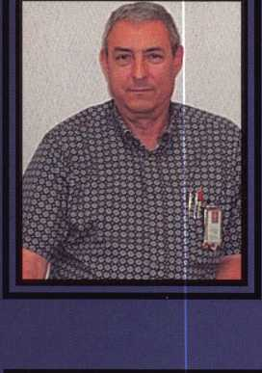

Although he holds locksmith work dear to his heart, Tucker points out that it has become just an ancillary part of his daily work.

“I still do locksmithing to some degree, because

I enjoy it, and quite honestly, sometimes we  
might not have anyone (in GSA) that can do

it,” he says. “It’s just an additional duty that I  
don’t get any extra pay for because, as I’m  
told, I’m getting paid more than enough as an  
Estimator/Planner.”

“If I walk up to a door or piece of furniture  
and find a loose screw, I can easily take care  
of it,” said Tucker matter-of-factly. “I can help  
out in a pinch. Having skills and the dexterity  
to do something with your hands is important  
to most people. I really feel sorry for those  
folks who can’t pick up a hammer or  
screwdriver and build something-or at  
least fix something simple.” /

approaches to how I’ll solve a particular problem. I’ve gained a certain degree of independence, or the right to look at a project from many different angles, before taking what I believe is the appropriate course of action.”

On a more personal, less formal note, Tucker  
is quite a handy man to have around. OK, so  
he doesn’t have a big tool belt strapped  
around his waist. He does, however, have a  
small Leatherman pouch with a flashlight,  
screwdriver, crescent wrench, and inside/out-  
side gauge. Who knows, if something ain’t  
broke, Chan’s probably fixed it a time or two.

Keynotes • April 2002

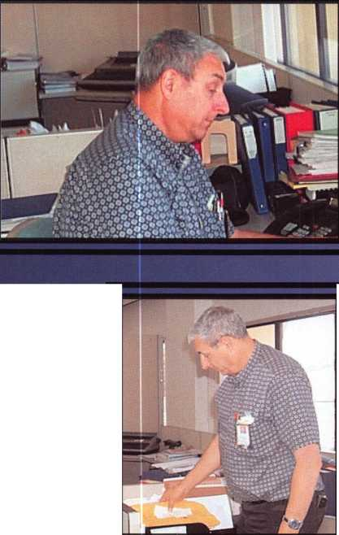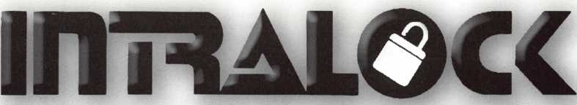

TOOLS LIMITED

**uiwui. intralocktools.com**

new

**affordable**

**price!**

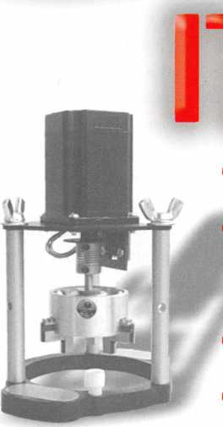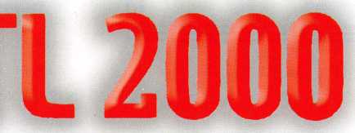

Super strong rare earth magnets  
Dial gripper with reversible shaped

jaws to grip most dials  
Easy to assemble mounting jig  
Self contained - no computer required

Phone: (888) 264-6627 A I f 2639-B Progressive U)ay

(604) 852-8904 **II I I tALVVX** Abbotsford, B.C.

USA: (562) 699-0060 **TOOLS LIMITED U**2**T**6**H**8

**Serving industry with superior products since 1985.**

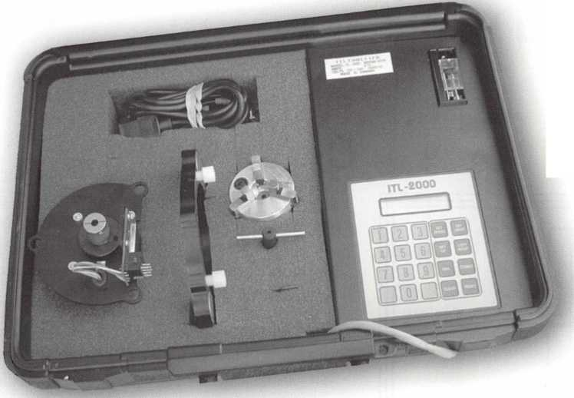

Techniques and

Variations

By Sal Dulcamaro, CML

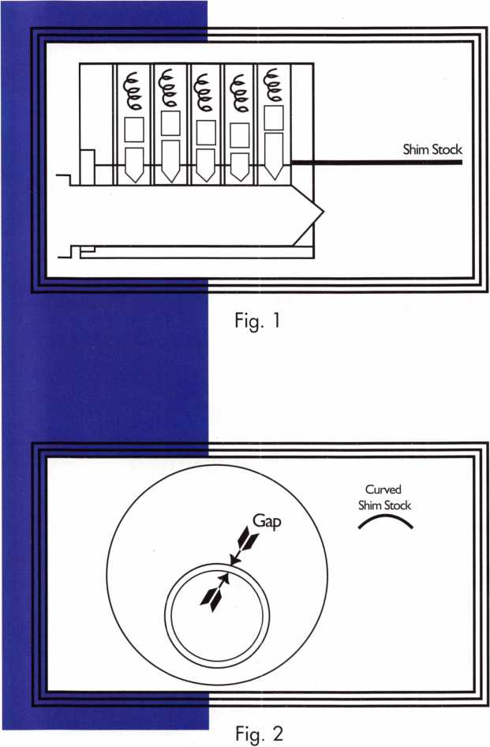

One of the fastest ways to disassemble a pin tumbler lock cylinder (when the correct operating key is miss­ing) is by shim picking. Shim picking does involve the manipulation of the pin tumblers to get the split points to the shear line, but it isn’t what many lock­smiths might call full-fledged lock picking.

When the operating key is available, it is usually used to move the pins to the shear line in order to remove the cylinder plug for rekeying or other necessary lock servicing. When an operating key is unavailable, it is a legitimate option to try to pick the lock cylinder and remove the plug when it has been picked. Because the length of time involved is often very unpredictable, it is desirable to have a method of plug rotation that is more consistently fast and reliable. With a little bit of knowledge and practice, it is rarely a difficult task for the typical locksmith to shim pick most common pin tumbler cylinders in order to remove the cylinder plugs for removal and service. On some rare occasions, you will find pin tumbler cylinders that are exceptionally difficult to shim pick. After explaining the more basic techniques of shim picking, I’ll cover some of the more troublesome situations.

The Basic Principles

For the most part, shim picking will not be helpful as a means of picking open fully assembled pin tumbler locks. Except for the extremely rare pin tumbler lock

**8**

Keynotes • April 2002



that has the shear line accessible from the face  
end of the lock (and such locks do exist), this  
technique will generally require that the lock  
cylinder be separated from the lock body or case  
and the plug retainer removed.

Figure i shows a side cutaway view of a typical pin  
tumbler lock cylinder. In this example a key  
blank has been fully inserted which lifts all the  
bottom pins directly into the path of the shear  
line. Shim picking requires you to have at least  
one piece of shim stock and something to manip-  
ulate the tumblers up and down within their pin  
chambers. If you are not familiar with shim  
stock, it is very thin sheet metal cut into small  
pieces. For use in shimming pin tumblers, you  
will probably want to go with the commercially  
available shim stock that is about .0015 inch  
thick. That is one and a half thousandths of an  
inch. It is extremely thin. If it wasn’t available  
already curved (matching the radial surface of the  
cylinder plug), it probably wouldn’t be sufficiently  
rigid for easy use in shim picking.

Shim stock must be inserted from the back end of  
the lock cylinder, into the gap between the plug  
and shell. The pin chambers should typically be  
positioned at about twelve o’clock in relation to  
the circumference of the plug (as if it was a clock  
face). Figure 2 shows the position where the shim  
stock should be inserted. Plug retainers will usu-  
ally block that gap, requiring the retainer be  
removed before shimming can take place.

Looking back at figure 1, notice that the shim  
stock has been pushed into that gap from the  
back end of the lock cylinder. When pushed  
inward, the shim stock travels a very short dis-  
tance before it hits the pin in the last chamber  
and comes to a stop. With the blank key insert-  
ed, the bottom pin blocks the shim stock. If no  
keys were in the lock, the tumbler springs would  
push the pin stack to the bottom of the pin  
chambers. In that case, the top pins (or drivers)  
would block the shear line. Techniques will vary

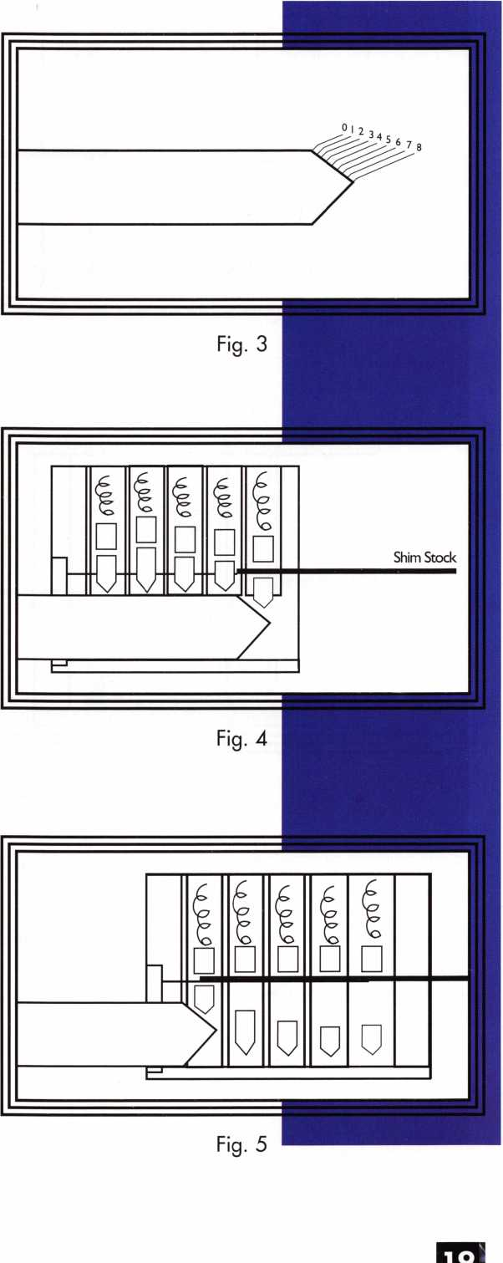

Keynotes • April 2002

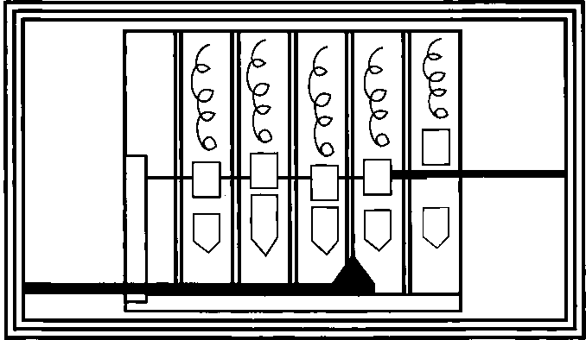

Fig. 6

|  |  |  |  |  |  |  |  |
| --- | --- | --- | --- | --- | --- | --- | --- |
| 1 1 | -i  □ | 1  0 | s  p | 1  p |  |  |  |
| P |  |  |
| —r |  | | | |  | |

Fig. 7

some depending on the types (by physical characteristics) of pin tumblers that you encounter inside the pin chambers.

Spool or mushroom top pins (and bottom pins on rare occasion) can complicate the shimming process. An alternate technique for dealing with spool/mushroom pins will be explained after the basic techniques are covered.

The Blank Key as a Manipulation Tool

When shimming a lock open, I will typically use either one of two meth­ods. The first method involves using a blank key to raise (or lower) tum­

blers to the shear line. The second involves using a pick to maneuver the tumblers up and down. I will explain the key blank method now, and the other method later.

Figure 3 shows a blank key with the angled tip calibrated to designate key cut depths. Starting with “o” as the full key blade height, it descends in equal increments as it identifies each depth consecutively deeper. A bottom pin, of the length identified by the numbers, should be positioned at the shear line if its tip rested on the matching numbered spot.

By moving the key blank in and out, it is pos­sible to move a pin to the shear line so that the shim stock could be pushed through the gap between the top and bottom pin. The primary limitation is that the pin chambers cannot be shimmed out of sequence. Since the shim stock cannot slide past a chamber that hasn’t already been shimmed, chambers must be shimmed in consecutive order last chamber to first.

When done properly, a blank key can be used to shim a chamber by either raising or lower­ing the pin stack in a particular chamber. With the blank fully inserted, all the pin chambers are blocked by bottom pins. If the blank is slowly and gradually withdrawn from the keyway, the angled tip will support the pin stack as it drops lower within the cham­ber and as the split point of the pin stack approaches the shear line.

The shim stock is pushed inward (lightly but constantly) while the blank is being with­drawn. The moment the pin stack’s split point matches the shear line, the shim stock can slide between the gap and separate the top and bottom pins as in figure 4. The shim stock travels a short distance as it splits the last chamber, and then it stops again when it hits the bottom pin blocking the shear line in the chamber just in front. The process can be repeated a chamber at a time until all five

**20**

Keynotes • April 2002

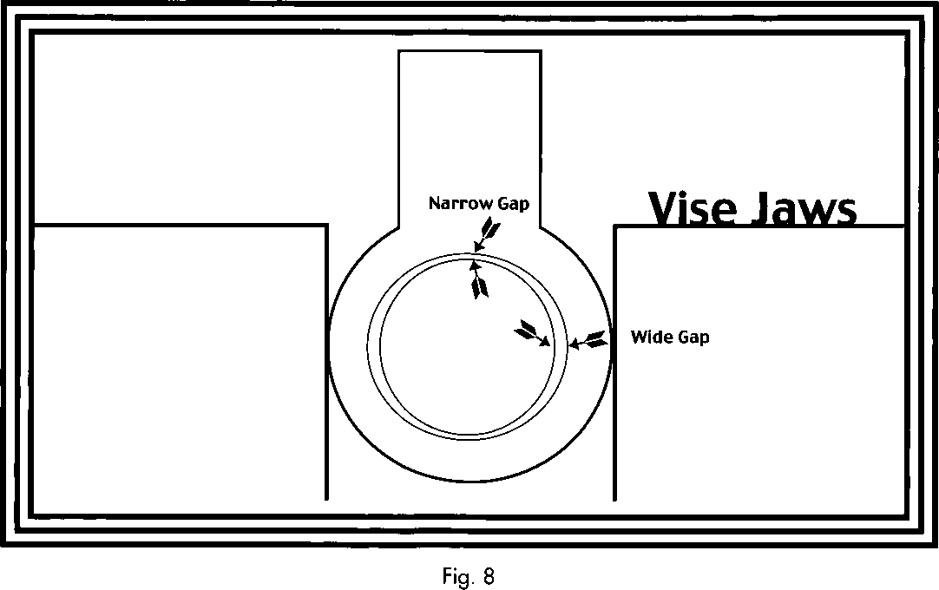

chambers are shimmed as in figure 5. Once all the cham­bers are shimmed, the plug can rotate and it can be removed for rekeying or servicing. If you miss or skip a chamber you can not continue to the next chamber just in front of that one. You must go back to the missed cham­ber and try again.

Difficulties and Complications

When you make another attempt at a missed chamber, you can try to repeat the action by pushing the blank far enough to move that missed pin stack up again.

Then withdraw the key blank more carefully to avoid missing the split point as the pin stack drops lower in the chamber. If the tumblers are sticky, bouncing or vibrating the key blank (while withdrawing it) can help the tumblers operate more smoothly as they descend in the chamber. Lubricating the lock will also be helpful.

Don’t be quick to presume that you missed a pin chamber. Though pin chamber spacing should be consistent, the pin

lengths vary and affect the distance traveled by the blank key before the pin stack next in line is shimmed. Shimming a chamber with a short bottom pin followed by a chamber containing a long bottom pin will cause you to move more than one full chamber space to shim the second one. Shimming a space with a long bottom pin followed by a short bottom pin can occur in less than a full chamber space.

In any case, if you think you skipped a chamber space, push the key blank in very gently and stop if you feel any resist­ance at all. If that chamber is already shimmed, the blank key can create enough force to push the shimmed bottom pin right through the shim stock. You can also try to shim a pin chamber while pushing the blank key inward. In that case, the split point of the pin stack in the chamber would be lifted up toward the shear line rather than dropping down as the earlier method showed. To use this method for all chambers, you must draw back the blank key until the furthest forward chamber (that is not yet shimmed) has its pin stack dropped to the bottom of the pin chamber. Then shim the chamber forward. Once you can feel the upward resistance caused by the shim stock, pull back the



Keynotes • April 2002

blank key to allow the next chamber toward the face of the lock to drop its pin stack to the bottom of the cham­ber. That would also be shimmed forward. The process would be repeated: backward, forward; backward, forward; until all chambers were shimmed.

Shimming With a Pick

Shimming with a pick would be similar to the process just mentioned without the in and out motion of the blank key. When the blank key is in the lock, the bottom pins block the shear line. With nothing in the lock, gravity and tum­bler springs will cause the top pins to block the shear line. When you shim by manipulating the tumblers with a pick, you still have to start with the last pin chamber (furthest to the back of the lock) and work your way to the front with­out skipping any in between. With the shim stopped by the top pin of the last chamber, you lift up the bottom pin of that same chamber as you gently push the shim stock inward.

Moving the tumbler up and down, the split point should eventually find its way to the shear line. When that occurs the shim stock should slip between the top and bottom pins and split that pin chamber. After travelling a short distance, the shim stock would stop against the side surface of the top pin of the next pin chamber forward, as in figure 6. The action would be repeated with the tip of the pick moving that pin stack up and down, until the shim stock found the split point and separated the pins in that cham­ber. After all five chambers were shimmed, the plug would be able to rotate and be removed to service.

Dealing With Spool Pins

To make a pin tumbler lock more pick resistant, some lock companies replace standard top pins with spool or mush­room shaped top pins. When normal picking is attempted, the narrow center of the spool top pins allows partial rota­tion of the plug. This gives the impression of individual chambers being picked and makes it very difficult to tell the difference between a picked chamber and a chamber with a spool pin.

Figure 7 shows some of the complications in shim picking caused by spool pins. When sliding the shim stock in the

gap, it is possible for the shim stock to start into a pin chamber somewhere other than at the split point of the pin stack. If you have a pretty good sense for how far the shim stock normally travels, you may realize when it happens. The movement needed to pass through an entire pin cham­ber (and the small extra space to reach the chamber that follows it) is measurably greater than the shallow penetra­tion into the narrow center of a spool pin. **You** may realize that the very short travel distance indicates you have moved the shim stock into the narrow center of a (spool) pin rather than between two different pins.

You can generally tell if your shim stock is in the narrow slot of a spool pin by the fact that the pick can move the pin stack up and down over a very limited range. If you push too high, though, you can feel the tumbler starting to grab and deform the shim stock.

To work around spool pins, push the shim stock in until it enters the middle of the spool. Then lift up the bottom pin with your pick until you feel the spool pin grabbing the shim stock. While maintaining light pressure with the pick, slowly pull the shim stock outward until the bottom pin starts to move further upward. Move very gradually now. Once you get out of the middle section of the spool pin, there is very little height to travel until you reach the bottom of the top pin. While moving the pin stack up that short distance, keep light inward pressure on the shim stock until the gap is found and the shim stock splits that particular chamber. If you keep on pushing the shim stock inward, you will probably penetrate into the middle of the next spool pin (if it is a spool pin). When you find yourself engaging a spool pin in the next chamber, repeat the process just given until all the chambers are split and the plug can be removed.

Tight Gaps

Tight gaps between the plug and shell are generally the biggest complication when it comes to shim picking. Sometimes there is an easy fix like lubrication of the lock, which gives just enough space to enter the gap. Sometimes the gap is exceptionally tight and the shim stock won’t enter more than a few chambers deep. Other times it won’t even go in at all. In those circumstances, I generally



Keynotes • April 2002

Associated Locksmiths of America, Inc.

International Convention and Security Expo



July 22-28, 2002 • Donald E. Stephens Convention Center/  
Hyatt Regency O’Hare • Rosemont, Illinois

EXHIBITORS

Compx Security Products Corporate Safe Specialists, Inc. Defiant Safe Co.

Desktop Dispatcher DETEX Corporation Dia Safe Inc.

Digital Systems, Inc.

Direct Security Supply, Inc. Don-Jo Manufacturing Inc. Doorking

Dorma Architectural Hardware Dugmore and Duncan, Inc. Dynalock Corp.

EZ Change Lock Co LLC Eclipse Ind.

Emergency Road Service Emtek

ESP Lock Products Inc.

Framon Mfg./Lockey Corp Frontier Safe Company Gardall Safe Corporation Hayman Safe Co.

HES, inc.

Hercules Padlocks High Tech Tools Homeowners Marketing Svs. Howard Keys HPC, Inc.

IDN Corporation Innovative Moving Systems, Inc. Institutional Locksmiths Assoc. IR Security & Safety Jackson Corporation Jet Hardware Mfg.co.

Joseph A. Thomas Ltd dba Bad Dog Tools KABA ILCO / KABA MAS Keedex Manufacturing

Keri Systems, Inc.

Key Systems

Knaack Mfg/WeatherGuard KSP

Kustom Key LA Safe & Vault La Gard Inc.

LAB Security Lockey Corp Lockmasters, Inc.

Locksmith Ledger International Locktools Company Lucky Line Products, Inc.

MAG Security MMF Industries Major Manufacturing, Inc. Markar Products Inc.

MARKS, U.S.A.

Master Lock Company MBA-USA, Inc.

MDS Incorporated Medeco

Meilink/Fire King Midwest Wholesale Hardware Mul-T-Lock USA, Inc Olympus Lock Company Omaha Wholesale Hardware OSI Security Devices PDQ Manufacturing PLS Group

Phoenix Safe International PRO-LOK

Pro-Steel Security Products Professional Business Products RA-Lock Co.

Rodman & Company ROFU International Corp Rutherford Controls Inc. - RCI

S. Parker Hardware Mfg. S.E.R.L.A.C.

Sargent & Greenleaf, Inc. SARGENT Manufacturing Co. ScanLock Schwab Corp.

Secura Key SecureRite.com Securitech Group, Inc. Securitron Magnalock Corp. Security Distributors Inc. Security Door Controls Security Lock Distributors Security Resources Inc.

Select Products Limited Senior Technologies, Inc. SentryLok, Inc.

Southern Lock and Supply Co. Southwest Specially Products Speedypik

Stone & Berg Wholesale STRATTEC Security Corp. Strong Arm Security, Inc.

Sun Safes Mfg.

Supra Products, Inc.

The Locksmith Store The National Locksmith Turn 10 Wholesale U.S. Lock Corp.

Ultra Lift Van Lock Co.

Videx

VingCard El Safe Visonic Inc.

W-Lok Corp

Wilson Safe Company

Yale Security Group, Inc.

Zipf Lock Co.

The ALOA Convention and Security Expo  
returns to the Midwest

1 -800-Locksmith A & B Safe Corporation-'

A-l Security Mfg. Corp Aable Locksmiths Abloy Door Security Abus Lock Company Access Hardware Supply Ace Lock & Security Supply Adams Rite Mfg. Company Adesco Safe Mfg. Company/ Star Safe and Alarm ADI, Inc.

Adrian Steel Company Advanced Security Products Alarm Lock Systems, Inc. Alden Corporation Allied Locksmiths of Illinois Allstate Insurance Company American Eagle Lock Co. American Lock Company American Security Products Architectural Control Systems Armadillo Firearm Security Products Arrow Lock ASP, Inc.

ASSA Abloy ASSA Inc.

Avco Key Supply Blackhawk Products Buddy Products Burg-Wachter BWD Automotive Alabama Camden Door Controls CCL Security Products Clark Security Products ClearStar Security Networks Commercial Van Interiors

Make your plans now to attend ALOA’s 46th Annual Convention and  
Security Expo. Our show always features cutting-edge classes for every  
type of security professional, and this year is no exception. World-class  
instructors will deliver top-notch ACE classes on a vast menu of security  
Topics to participating students. Plus, a stroll across the show floor at  
ALOa*s Security Expo gives attendees a perennial who’s who in the  
world of security product manufacturing, with hot deals to be had at  
every new turn. The latest and greatest is always yours at the annual  
ALOA show. It’s the biggest security bonanza in existence and we’re  
landing in the Chicago area for the first time in nine years! It’s just  
one more reason to celebrate how far we’ve all corne-  
as well as where we’re going.

maid E. Stephens Convention Center in lovely Rosemont boasts iss facilities in addition to being among the nation’s top 10 t and most versatile show facilities. It’s the perfect spot for the ALOA Security Expo.

Our h

thej

b\y

el this year is the Hyatt Regency O’Hare, located right next to

d E. Stephens Convention Center (and conveniently connected

lk). The hotel features plenty of on-site entertainment, including  
ateries, an indoor pool, exercise facilities and a rooftop atrium

restaurant with breathtaking views.

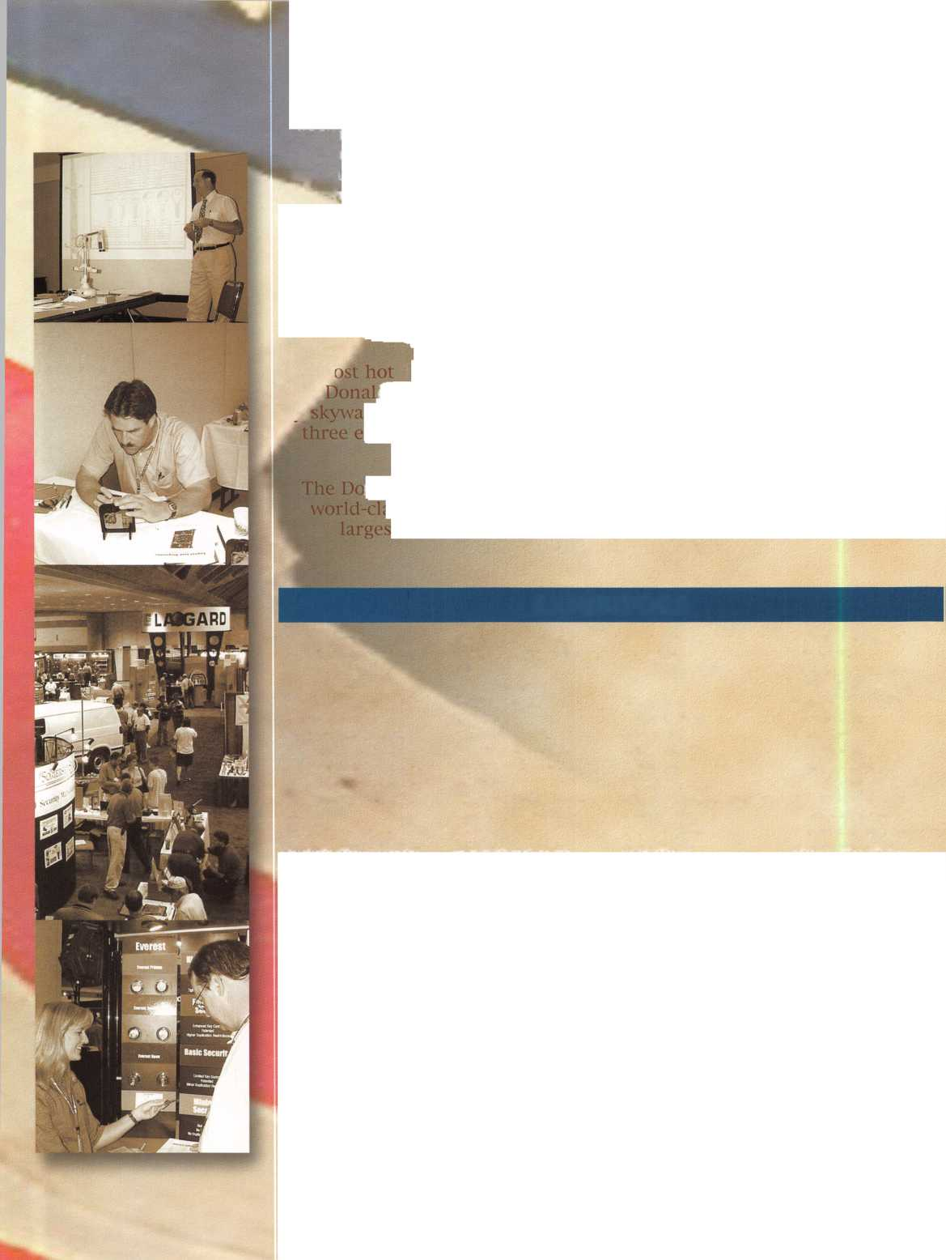

milm Your Reservation Now!

Your individual success as a locksmith is what the annual ALOA convention is all about.

Make a secure investment in your future!

Request your complete registration packet today and take advantage of the best selection of classes and travel accommodation values.

Classes for ALOA 2002:

Telepho

Email

Name

Company

Address

Slate

Basic Electricity Introduction to Access Control Basic Electricity

Electronic Access Control Entry Level Installer (2 days)

AMSEC Electronic Access Control Certification

Folger Adam Electric Door Controls

l-Que Elec. Access Control Certification

Introduction to Access Control with Cyberlock

Videx Cyberlock Advanced Training

Proximity Access Control by SecuraKey

Alarm Lock Trilogy Certification

Complete Guide to Electric Strikes

Millenium Entry Systems

The SafeWizard™ Access Control System

LOCKSMITH BUSINESS CLASSES:

What is my time worth? OR How much should I charge?  
Financial Management for Locksmiths (2 days)

Business Planning  
Advanced Shop Management  
Increase Your Revenues by 25% This Year  
Making $ Selling Cash/Handling Safes  
Instructor Training (3 days)

Improving Security in Your Business Community  
Replacing Lost Keyless Entry Remotes-An Untapped

Market for Automotive Locksmiths

For more information, contact the Associated Locksmiths of  
America by using this form, fax, email or check out our web-  
site at [www.aloa.org](http://www.aloa.org).

I

Q Register me for Exhibits Only (members: FREE when received before 6/21/02, nonmembers: $10) □ Send me more information

TRADITIONAL LOCKSMITHING CLASSES:

Fundamentals of Locksmithing (5 days)

Basic SFIC, Corbin Russwin, Schlage and Yale 1C hands on

Master Keying Methods & Formats (2 days) Advanced Topics in Master keying Exit devices & Exit Alarms Servicing Aluminum Storefront Doors Complete Door and Door Closers Hollow Metal Door & Frame Servicing Medeco Biaxial Factory Certification Investigative Locksmithing (3 days)

Forensic Locksmithing Life Safety Codes and ADA Detex Advantex

Studying for and Passing the PRP Professional Bypass Techniques Mechanical Push Button Lock Manipulation Comprehensive Interchangeable Core (2 days) Simplex Unican Certification Servicing Schlage Commercial Products American Padlock Certification Master Pro Series Certification Mul-T-Lock

Medeco Keymark Certification Medeco New Product Update Primus/Everest Certification Rekey Project Management ABUS Padlock Certification ASSA High Security Locks Product ABLOY PROTEC High Security Locks Electrified Closers and Door Controls HPC Codes & Code Machine Concepts Key Systems & Automated Key Production

Yale Cylinders & Master-keying Certification

Fire Door Hardware

Van Lock/VanTech 21

PDQ Revolution Mortise Lock Program

SAFE & VAULT LOCKSMITHING CLASSES:

Basic Safe Penetration Kaba Mas Series Locks

Kaba Mas-FF-L-2740A Approved Lock Certification Safe Combination Lock Servicing & Troubleshooting Combination Lock Manipulation (2 days)

S&G Group 2/2m Certification

S&G Electronic Lock Certification

LaGard Electronic Lock Certification (2 days)

AUTOMOTIVE LOCKSMITHING CLASSES:

GM Steering Column Service/Repair (2 days)

Basic Automotive Lock Service  
Intermediate Automotive Lock Service  
Advanced Automotive Lock Service  
Motorcycle Locksmithing  
21 st Century Car Opening  
Transponders 2002  
Automotive Key Generation  
STRATTEC 2003  
13 Methods of Car Opening  
2002-2003 Kaba llco Automotive Update  
Transponders 2002/2003  
Automotive Picking Techniques  
Auto Opening Techniques 2002

ELECTRONIC LOCKSMITHING CLASSES:

Electronic Safe Lock Servicing

Alarm Design and Development (2 days)

Comprehensive Access Control (2 days)

Mail, Fax, or Email the above information to: Associated Locksmiths of America • 3003 Live Oak Street

Dallas, Texas 75204 • Fax: 214-827-1810 • Email: [convention@aloa.org](mailto:convention@aloa.org) • Phone: 214-827-1701 or 1-800-532-2562

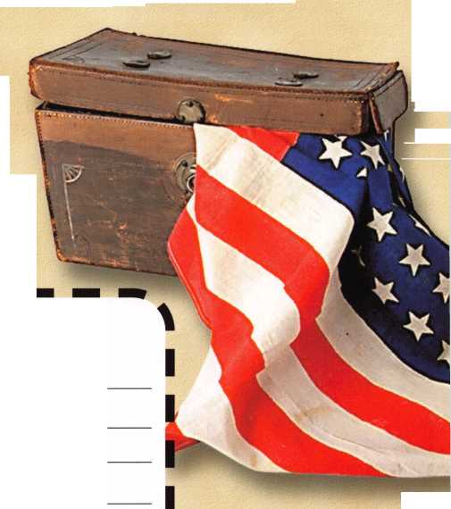

Associated Locksmiths of America, Inc.  
ALOA 2002

International Convention  
and Security Expo

3003 Live Oak Street  
Dallas, Texas 75204

(214) 827-1701 phone  
(214) 827-1810 fax  
[www.aloa.org](http://www.aloa.org)

SPONSORS:

**Abloy**

**AMSEC**

**ASSA**

**Adesco Safe Manufacturers  
Clark Security Products  
Garda 11**

**IR Security & Safety  
KABA, KABA ILCO, KABA MAS  
La Gard Inc.**

**Lucky Line Products  
AAAG Security  
Medeco  
Mu I-T-Lock  
Sargent**

**Sargent & Greenleaf, Inc.  
Silver Sales  
STRATTEC, INC.**

**W-LOK Corp.**

**Yale Security Group Inc.**

PRSRT. STD.

US POSTAGE  
PAID

DALLAS, TX  
PERMIT NO. 7274

try to insert the shim stock as far as I can. When dealing with tight gaps, you should always lube the lock first.

If I can only shim two or three chambers, it generally leaves me with only two or three pin chambers still locked. In that circumstance, I will generally try to pick the remaining pin chambers as if I was dealing with a lockout. Although not necessarily easy, it will generally be less diffi­cult to pick than if it had all five chambers still locked.

Key-in-knob and similar style lock cylinders generally have lock shells with a rather thin wall that surrounds the plug. On occasion I have found locks that were too tight to shim. Figure 8 shows one version of that circumstance. While the plug in the center is fairly round, the inside walls of the shell are sometimes shaped more like an oval. The gap at twelve o’clock (where the pin chambers are located)

is much tighter than the much larger gaps on each side at about three and nine o’clock. In some cases I have tested the large side gaps by being able to insert two or three pieces thick of shim stock. If you are careful, you can mod­ify the out of round condition by gently squeezing the side surfaces of the shell in a bench vise until the side gap closes slightly and the gap at twelve o’clock slightly grows.

You only need a shift of about one or two thousandths of an inch to gain enough room for the shim stock. Squeeze very carefully. If you go too far you can ruin the cylinder. Never try this on a mortise cylinder; you can damage the threads. Not every lock cylinder can be effectively shimmed, so don’t sweat it if you have to admit defeat to a few lock cylinders here and there. With practice, though, most will be a piece of cake. Q

Travel Fast & Easy  
with Avis.

Avis takes care of you for business or pleasure.  
Our special meeting rates and discounts makes  
it easy for you to incorporate leisure fun into  
your plans.

Your special low Avis rates are good from one week before to one  
week after your meeting so you can take in the sights and explore.  
"We try harder" to help you enjoy your meeting with great rates and  
time saving services.

Call 1-800-331-1600 and reserve your Avis car for this meeting.

Be sure to mention this special meeting Avis Worldwide Discount  
(AWD) number: B466699

Associated Locksmiths  
of America Convention

July 22-28, 2002

AWD # B466699

AVIS

NVet^,

harder-

Avis features GM cars.

©2000 Avis Rent A Car System, Inc.

Keynotes • April 2002



THIS YEAR'S

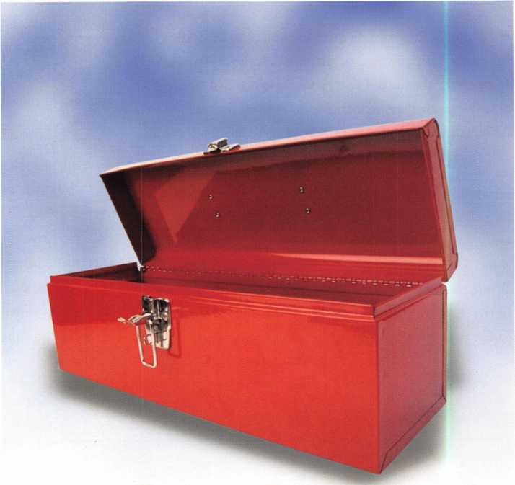

By Don Dennis, CPL

Locksmiths and their tools make a complete package. One without the other would be inconceivable. This year’s offering of fascinating tools not only gave excitement but also boosted the skill level of those participating in the offerings.

There seems to have been two ways in recent years for locksmiths to participate in their profession. One way was through force and the other way of course was through the development of skills. It is not that force does not have its place, it does! When all else fails, use force. A good philosophy but in many cases force leaves the customer, the on looker, won­dering why they hired someone to tear up one of their prize possessions. It is not that the locksmith will not fix the dem­olition but the customer draws an eerie sense of being tricked or violated. Skill on the other hand, leaves the customer with admiration at your ability of solving the problem and they look upon the experience as magic.

Tools that require skill development, take time to come to the marketplace thus encouraging the development of forceful techniques. Once the tools are in the locksmith’s hands, the general rule is that as the skill develops time is saved. The old adage of time is money kicks in. This year the following tools seemed to have come to the forefront.



Keynotes • April 2002

Flip Pick: I know that many would say that the  
Flip Pick does not require a skill level. When you watch  
the pick doing the work in the hands of an experienced  
operator, I would agree. It looks simple and easy. Isn’t that  
what skilled work is suppose to look like? Once you have  
picked up a pick and begun to work with it, you realize  
that the skill is in the form of the application of applied  
tension. Too much or too little tension and nothing hap-  
pens except frustration. When you do apply the right  
amount of tension, the ease of the opening not only sur-  
prises the customer but it even surprises the operator.

The application of this tool is simple. You insert the tool  
and the tension wrench. Then removing the tool quickly  
and in a smooth motion while keeping the proper amount  
of tension and applying a little bit of a wiggle and the cylin-  
der turns. You actually will pick the cylinder to the locked  
position and then use the plug spinner. The spinner will  
very quickly move the picked plug from the locked position  
to the unlocked position before the tumblers can fall and  
relock the cylinder. Sounds simple, don’t you think? Believe  
me, it is all in the tension and the wiggle. Randy Mize is  
the locksmith/inventor of the Flip Pick and it is my under-  
standing that besides the current 2 and 4 track BMW locks  
that it now opens, others manufacturers are under consid-  
eration. Of all of the tools in this  
article, this one was the easiest

one to learn requiring little  
knowledge of the actual lock that  
is to be opened.

SKT-i : The SKT tool is a  
beautiful tool. It is the one tool  
for this past year that holds the  
most promise of being the most  
versatile for the money spent.

Sam Kang living in Toronto,

Canada is the inventor. If you  
have a wafer lock that needs a  
key, the SKT may give you all of  
the information needed. The  
advertising will tell you that it  
works on Ford’s 8/10-cut autos,

GM’s 10-cut vehicles, and  
Chrysler’s 7/8-cut products. I am  
finding it more versatile than that  
if the blades and readers will  
enter the desired wafer lock.

I am not saying that this tool is an easy walk in the park.

It isn’t! Given the proper time to learn the skill of its use,  
the SKT will be a tool that will become invaluable in the  
art of wafer key production.

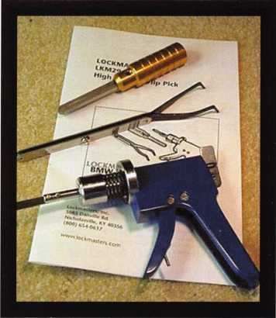

Flip Pick Photo - The Flip Pick works the BMW 2  
& 4 Track Locks and comes in an attractive  
protective plastic case.

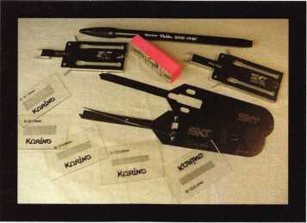

SKT-1 Wafer Reader Tool Photo-This photo only  
has a part of the entire tool's composition.  
There are four readers and blades, four guides,  
several gauges, pads, and ink pens. The entire  
kit comes in a plastic case with individual plastic  
boxes inside of that protecting the tools.

The tool  
inserts into  
a lock and  
then a slide  
is drawn out  
of the lock,  
which draws  
a stepped  
wafer tum-  
bler pattern  
on the  
attached slip  
of paper.

The learn-  
ing curve is  
in the two  
parts of this  
tool’s usage.

First, is

keeping the tool absolutely perpendicular to the face of the  
lock as the slide operates. The second is in the deciphering  
of the cut pattern that is produced. There is furnished with  
the kit acetate scribed with the cut levels for the Ford, GM  
& Chrysler products. Using this acetate by overlaying it on  
to the SKT results paper, you can decipher the cuts for the

future key.

Should you decide to decrypt a

lock that is not represented on  
the acetate film then you will  
need some practice with and  
knowledge of that particular lock.  
Many times, however, it will be  
possible to decipher the cut pat-  
tern scribed on the paper and  
impression a key or cut a key by  
use of space and depth keys. As  
your skill improves with this tool,  
you may even be able to simply  
file out the proper key once you  
have seen the SKT results. I have  
seen those fellows who do a bit of  
showing off. They will pick a  
wafer lock just enough to hold  
tumblers in the picked position  
and then with an otoscope view  
the picked tumblers and on their  
knee file out the proper key. This

is what your skill level could reach with the learning of the  
SKT’s capabilities. The only difference is you will not need  
to pick the lock to decipher the cuts. That in my book is a  
big deal!

Keynotes • April 2002

PRO-iE: This tool picks the standard tubular style  
locks. It is the same tool as the PRO-i without all of the tips.  
Ken Perrson an inventor/manufacturer out of East Rochester,  
New York invented this PRO-i pick series. The PRO-iE  
comes with only the standard 7-pin tip installed. Should you  
want more tips in the future, you simply order the new tips  
when you are in need of them. The reason for this chopped

down version of the full-blown  
tool was in reducing the cost of  
the tool. I should mention that  
the PRO-i has had a price  
reduction due in part to better  
manufacturing procedures. This  
makes the PRO-iE even more  
affordable.

Since I mentioned tips, the  
other tips, other than the stan-  
dard 7-pin (L7), that can be  
ordered are: the 8-pin (L8) (for  
picking 7 right, 7 left, and 8-  
pin), the 7-pin narrow (S7) (for  
picking bicycle padlocks and  
the like), and the 7-pin  
deep/narrow (DN7) (most  
notably used for picking  
American 7300 padlocks). I

have heard from the inventor of the PRO-i that other tips  
are on the drawing board but as of now I do not know  
what they are or when they will be available. We could  
probably make a few guesses but not here.

The one thing that makes the PRO-i series of picks a good  
deal is that at a reasonable price you obtain a wide rage of  
versatility. It is a single tool that will pick most of what is  
out there in the everyday world of tubular locks while the  
inventor/manufacturer continues a diligent effort for keep-  
ing the tool current and up-to-date. It is the versatility that  
is offering more bang for the buck!

This is not to say that the PRO-i series is a magic wand. It  
is no more a magic wand than a pouch of your best picks.  
You use the skill of picking your entire career and you only  
improve with practice and effort. The PRO-i series is the  
same thing. It is a pick, which will require a level of profi-  
ciency if you are to earn your degree as a “James Bond”  
equivalent in the eyes of the customer. It is a tool, which  
can make you a competent adversary for almost any tubular  
lock situation.

Conclusion: This has been a wonderful year for  
professionally oriented tools. There are always those tools  
that come to the marketplace that are guides for drilling, or  
a better drilling bit, or a better screwdriver. These amount  
to helpful items that accomplish a job that you have already  
learned. They may, because of their new design make the  
job faster or easier. When we talk of skill levels in terms of

tools, we leave the area of conven-  
iences and focus on tools that lend  
themselves to our proficiency in  
the science of locksmithing. The  
SKT Wafer Reader Tool is not for  
the novice or even for a two or  
three year apprentice. You really  
cannot measure this sort of thing  
by time in as much as proficiency.  
You need a complete knowledge of  
wafer locks from the construction,  
to application, to picking, and  
impressioning in order to fully  
understand how this tool does its  
work. You need to know that  
forceful effort in the use of a tool’s  
application may not be as useful as  
a gentler approach.

I can reiterate these same concerns

with the PRO-iE. You have to know the product that you  
are trying conquer. A working knowledge of tubular locks  
is imperative as well as the history of how the lock has  
been transformed over the years in order to have a better  
level of success. Without the knowledge of these things  
then a novice will simply need to understand that the learn-  
ing curve required will be a greater period of time than  
someone well versed. This is not a problem so long as we  
all remember that we need patience in our work and that  
very few of us were masters when we entered our trade.

I wish to give Tom Seroogy of Lockmasters special thanks.  
He allowed me access to a couple of the tools that were in  
this article and several that I did not discuss. I admire a  
company like Lockmasters (1-800-654-0637 or [www.lock-  
masters.com](http://www.lock-masters.com)), who will allow someone like me to see a  
group of tools and make an evaluation without pressure  
of giving positive appraisals. I had difficulty with the SKT  
tool and Tom hung in there with web site help as well as  
telephone conversations. I had a tough time learning the  
PRO-i series tool as well. I have been is the industry as an  
active locksmith for 30 years and have but one thing to say.  
Who says you can’t teach an old dog new tricks! Q

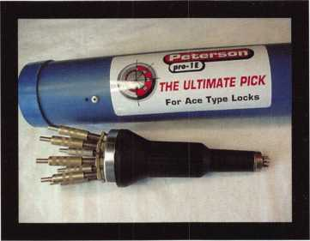

PRO-1 E - The PRO-1 E comes in a PVC container that contains a protective compartment for the tool to rest. The top of the cap is hollow to allow for the storage of additional tips and Allen wrenches.

Technical Editor's Note: The correct term for "Wafer Lock" is "Disk Tumbler Lock".



Keynotes • April 2002

Accept no CHEAP SUBSTITUTES.

Participate in the only van and storefront contest that PAYS!

ALOA is now accepting photo entries for the all-new 2002 van and storefront contest. In reclaiming  
the old contest, we've made some great updates. Prizes will be given out to the top three winners,  
who will be announced on the show floor at ALOA 2002 in the Chicago suburb of Rosemont, IL.  
(Winners do not have to be present to claim prizes.)

All you have to do for your chance to win one of three great prizes is submit a printed picture of your  
storefront or van (complete with contact information) to the following address: ALOA Van and Storefront Contest,  
3003 Live Oak St., Dallas, TX 75204. Or, simply e-mail a high-resolution photo in JPEG format (no files over  
3 megabytes will be accepted) to: [editor@aloa.org](mailto:editor@aloa.org). (Note: Make sure to write  
"ALOA Van and Storefront contest" in the subject header of the e-mail.) Good luck and  
may the best van win! (And the best shop front too!)

Entries accepted now through July I, 2002.

Hurry now to be a part of the original ...



By Greg Perry, CML, CPS

That big hotel in town has asked for a rekey bid.

You’ve eyed this account for a quite a while.

The competition has been servicing them, but this  
time, you underbid them and have the job to master key  
all the rooms. You cut all the keys and ask the manager for  
a master key to take apart the cylinders. Let’s get this job  
going. But wait, something looks a little different about  
the master key. Someone has added some square cuts to  
the bottom of the key You wonder why, but figure it’s  
just the crazy untrained maintenance man not under-  
standing how to cut a key Taking the cam off the  
back of the mortise cylinder and pushing the fol-

lower through the cylinder, you notice some  
small “broken” looking rings fall off the plug.

Now what to you do? Welcome to the world  
of Schlage warded cylinders.

Schlage has been using warded cylinders  
for many years. I have also heard these  
rings referred to as “blocking” rings.

Originally, warded cylinders had two

totally different uses. First, many  
years ago, they were used  
as a method to enlarge mas-  
ter key systems. The second  
use is what you’ve found: to allow  
the plug of a hotel mortise cylinder to

only turn one direction. The ward rings prevent a  
key from turning one direction unless the bottom of the

key is notched or cut in that position. Hotel cylinders are hand-  
ed; a right hand cylinder will allow the cylinder to turn clock-wise for use  
in a lock mounted on door with the hinges to the right of the lock. Reverse bevel  
or standard doesn’t matter. Why limit the turning direction? Hotel mortise locks use the dead bolt  
to provide the privacy lockout. A Schlage L9085 is a storeroom function lock with the addition of



Keynotes • April 2002

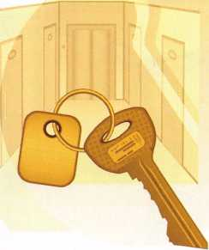

the dead bolt for night security and an occupied indicator. When the dead bolt is thrown, the maid’s key and the room key should not open the lock. All keys except the emergency master key should only retract the latch bolt. Only the emergency master key should unlock the door if the dead bolt is thrown.

So how is this accomplished? The plug has seven grooves cut around the plug as seen in photo i. These are where the ward rings seen in photo two are placed. The hotel cylinders I’ve seen use the four slots between the first and fifth chambers. The cylinder housing has two slots or chan­nels cut into it at about the 5:30 and 6:30 positions. These slots seen in photo three are for the tabs on the ward rings. A right hand cylinder would have the four ward rings placed on the right side of the plug. This will block a key without the ward cuts from turning in a counter-clockwise direction. A left-hand cylinder would simply have the rings installed on the opposite side. Keying the cylinder is done as most cylinders are pinned, bottom and master pin installed in each chamber. The difficult part is coordinating the re-assembly with the ward rings in place. First, make sure no master wafers are left in the housing and the prop­er top pins and springs are in place with a follower holding them. Place the ward rings on the plug in the appropriate

Photo 3

grooves with the  
tab toward the bot-  
tom of the plug.  
The rings do not  
have to be in the  
exact position they  
will be in when in  
the cylinder.

I try to keep the  
tabs near the pin  
chamber holes in  
the plug. It helps to

keep the plug turned or rotated to have gravity working  
with you keeping the rings in place. The rings are in place  
on a plug seen in photo four. Now turn the housing hori-  
zontal; with the slot that you want the ward rings to go  
into up. Slowly insert the plug rotating it slightly as is goes  
in to align the tabs to the slot in the housing as you go.

This is usually easier said then done, but with a little prac­tice it does work.

The emergency key blanks can be ordered from Schlage, but why bother? If you have a slotter and a Framon code machine, you can make your own blanks. Change the cutter out to the .055 slotter. Insert a key blank upside down in

Photo 1

Photo 2

Most hotels have switched over to card reader-type locks but plenty still exist with mechanical keys and cylinders.

Keynotes • April 2002

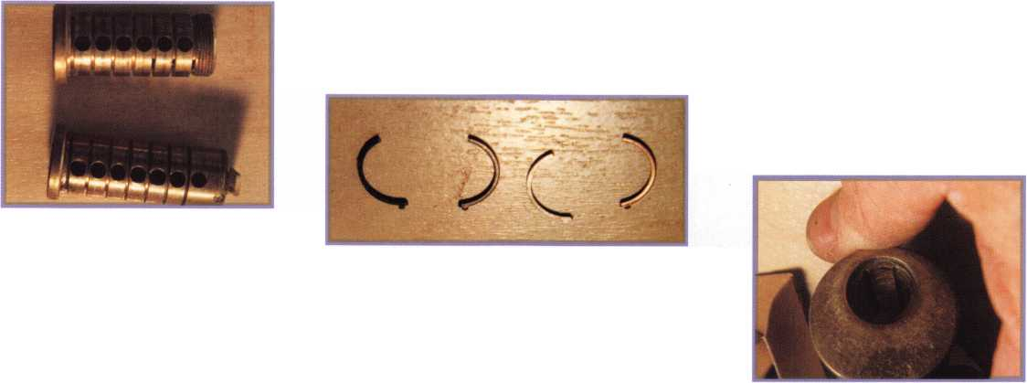

the jaw and align the top shoulder to the edge of the vise  
jaw. Moving the carriage to .190 will align the cutter to the  
first ward cut needed for a hotel cylinder (this is the sec-  
ond groove of the plug). The depth of the ward cut is  
.030. On my machine, the cutter touched the blank bot-

tom at .340, which means you need to set the depth to

.310. Cut this position and move the space over .156,  
repeat until all four ward cuts have been made.  
Photo five shows the key blank with the ward  
cuts. Photo six shows it in the plug; you can see  
how the ward cuts align with the grooves cut in  
the plug. I haven’t tried cutting the ward cuts on  
an HPC 1200 machine, but with a little thought,  
it could be done. Accuracy is not required since  
these are ward cuts; they simply need to be large  
enough. Too big is not a problem unless you widen  
the cuts so large that they match the pin chambers.

You would then run the risk of having number 2 mas-

ter wafers jammed in the ward cut. These cylinders can

be a challenge to work on; therefore we charge dou-  
ble our rekeying rate to work on them. The ward  
rings seem to fall off at just the wrong moment  
and get lost under the bench. I finally ordered  
some extras just in case.

One thing I love about this business is there is  
always something new to learn, even if it’s an old  
design. Most hotels have switched over to card-read-

er type locks, but plenty still exist with mechanical  
keys and cylinders, perhaps even in your service area.

The first time I ran across a warded cylinder in the field  
was only a couple of years ago. No, I didn’t underbid the  
competition to get the account. They had a maintenance  
worker with a pin kit and a factory chart performing their  
work. When he quit, they brought me the charts and a  
couple of cylinders to rekey. I’m glad they didn’t ask for a  
complete rekey price before I worked on a couple of cylin-  
ders, because I would surely have underbid it! Q

f

Keynotes • April 2002

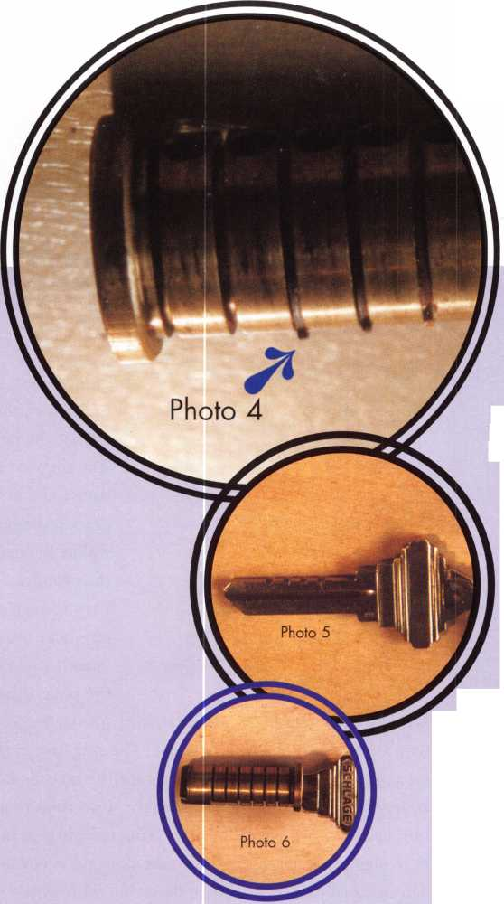

• • #*

' * #

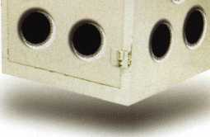

**April 8-13 John Ascuaga's Nugget Resort • Reno, Nevada**

r — - ~ "" —i

reno, nevada



2

*w \**

Wk\ *\4k*



ijETlc

3Mm *1

y§ar$^

ME*£

Forget the lug door; let me admire the vault first.

They just don’t make them like this anymore



**,**

tfe,Tf

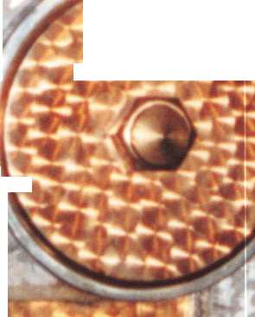

Another Opportunity

By Greg Perry, CML, CPS

S

everal months back, I wrote about an opportu-  
nity that I had to document a bank vault door.

This month, I had the opportunity to docu-  
ment a Mosler bank vault door after I opened a  
Mosler GSA (General Services Administration) lug  
door safe that was inside the vault. It started with a  
phone call from a friend regarding the lug door.

Could I open the lug door tomorrow morning? The answer of course was, yes! The only Mosler lug door I’ve opened up to this point was at the SAFETECH 99 in Las Vegas. That was a group opening and not exactly the best way to open a safe if you want to repair it after you get it open. (See “The Toughest Class” Safe & Vault November 2000 for the story). I’ve drilled lots of Red label hardplate and other TL-rated safes, so I wasn’t concerned. I’ve also serv­iced plenty of them. Next question, HOW much? Since there are many different versions of lug doors,

I went out to look at the safe. Every time I quote an unknown safe without looking first, I always seem to underquote. I wanted to make sure I had room to work and get an idea of the particular model I was up against. As I walked into the building, the vault door caught my eye. Forget the lug door; let me admire the vault first. It’s like going out with a good-looking

lady only to see an  
absolutely stunning  
beauty nearby; you can’t  
help but be attracted  
and at least look a little.  
My wife jabs me in the  
ribs for looking; I think  
she jabs me more for  
looking at vault doors  
and safes then she does  
other women. Right now  
I needed to attend to  
the lug door. The vault  
door would still be there

when I finished.

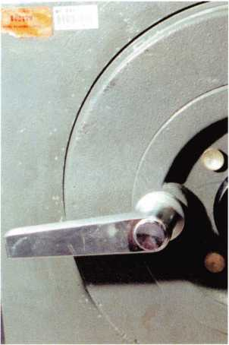

3. The mini rig drilling into the safe

Entering the vault, I saw my opponent. At first glance, it didn’t look like anything special, just your common newer lug door. I saw a label below the hinge indicating it was a Class 5 GSA container.

The dial contained the “butterfly” knob in the center, meaning the lock inside was an S&G 8400 series lock. Still not concerned, I quoted a price that was accepted. I planned on a top or side drill, scope the change keyhole, repair the hole, service the lock

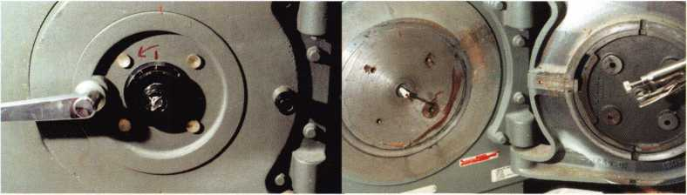

1. Mosler GSA Lug Door

2. The mini rig drilling into the safe

Keynotes • April 2002

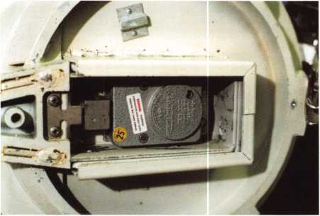

4. Inside view after removing back pin cover

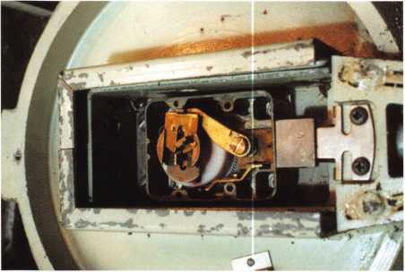

5. Cover of the lock removed

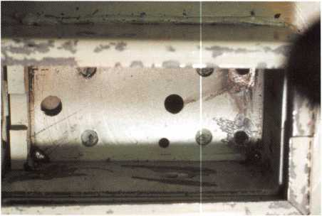

6. At the shadow line, you can see where the drill came out.

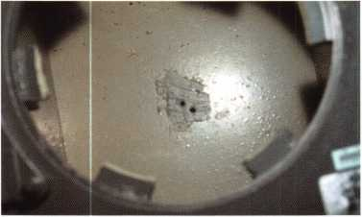

7. A look at the back where someone else had back drilled

and collect the money. Returning to the shop,

I pulled out my books to confirm lock handing and see if there were any special features or considerations before drilling. Am I better to top or side drill? After a little research, I found neither option was appropriate. The GSA doors use a right-hand lock mounted left hand.

Mosler also completely encases the lock body with hard plates like file cabinets and Comsec safes. I posted a picture on the SAVTA.org web site just for a little moral support. The respons­es I received ranged from incorrect to Good Luck! Overall, I received some great advice and firmed up my plan of attack.

The next morning, armed with the correct information, I started the opening. First step is to remove the dial, the dial ring and the hinge crane. I drilled and tapped three of the four dial ring mounting screw holes into the door for mounting the StrongArm Mini-Rig template. After setting up the Mini-Rig and drilling the door face with a 9/32” high-speed steel bit,

I switched to a 1/4” carbide. The hardplate used in these chests is “Relsom.” It can be some tough hardplate! I expected the carbide to polish the surface a little preparing it for a diamond-core drill. I was pleasantly surprised when it started cutting. I let it cut for about 1/8” before pulling it out to check progress. I could see a shiny spot in the center of the hole. Time for a diamond-core drill. Slowly, I used the diamond to grind my way through the “Relsom.” Every 1/8” or so I use a carbide to clear the hole. Sometimes they will start cutting again, other times all you do is remove the cen­ter core and start back with the diamond. The other option is to drill and punch your way through the hardplate, not a fun job. Most of the time when drilling tough hardplate, I use a combination of diamonds and drill and punch. About 90 minutes later the hole was to the lock case. I switched over to some flat sharpened bits to enter the lock case. Once in, the lock was dialed open. At this point, it’s a good idea to reattach the hinge; the door can be very



Keynotes • April 2002

heavy. I spun it and pulled it open. What I found inside was interesting. Someone had pre­viously removed the inner back plates that nor­mally would have prevented scoping or back- drilling the safe. Not only were they gone, but someone after that had back drilled to scope the change keyhole. I repaired the hole with a “Safe Saver” carbide pin, cleaned and serviced the safe. Once this job was complete, I asked for permission to take some pictures and docu­ment the vault door.

The vault door has seen better days. There is a little rust on it, the glass is missing from the inside cover of the door and the cover lock is broken. It has not been used for at least 15 or 20 years. Still it is a beauty. Both the inner and outer door surfaces are jiggered. The hinge crane, although now painted black, originally appeared to have some gold leaf stripes and an ornate Mosler emblem. The inner bolt tracks are also ornately decorated. Even the transfer mechanisms have the jiggered surface. Looking a little closer at the locks we see a two-move­ment Yale and Town time lock. The combina­tion lock, I’m told by Kenny Hiemstra, is a Mosler KC11; it is an offset drive lock. They just don’t make them like this anymore.

I always try and document every safe and vault I can. Sometimes they present themselves while doing other jobs, like this one. I have sent all the drill points and specific information on both doors to Mike Oehlert at the SAVTA technical desk. If you’re a SAVTA member and need more information, check with Mike or myself at [glmperry@iwvisp.com](mailto:glmperry@iwvisp.com). You can also find more information on the SAVTA.org web site. ALOA members are always welcome to join the Clearstar web site that hosts the SAVTA.org web site. From there, you can enter the SAVTA site. Most of the guys and a few gals there are more then willing to offer great support and advice on all aspects of lock and safe work. Q

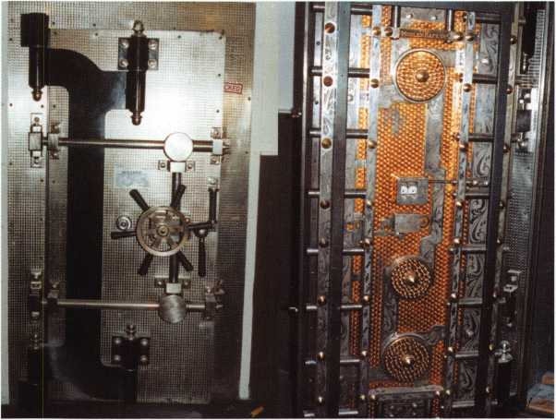

8. Outside of the vault door 9. Inside shot of this beautiful door

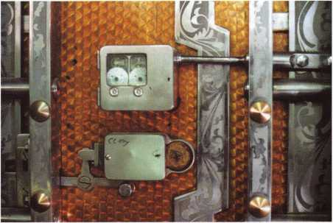

10. Close up of the lock area

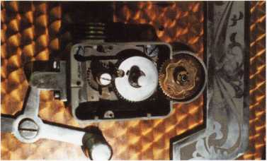

11. Cover and wheel pack have been removed

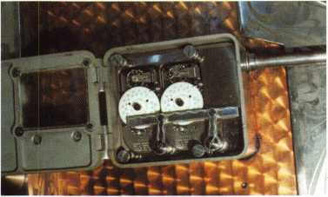

1 2. Close up of the Yale & Towne timelock

Keynotes • April 2002

**RIGHT**

**Voice**



S

everal months ago, our industry lost a valuable

member of the locksmith community This person

was not a skilled craftsman. This person may never  
have taken a lock apart and successfully put it back togeth-  
er again. However, this was a highly skilled professional.

This was someone who respected customer’s wishes.

This was a person who never tried to make the fast dollar; striving to keep existing customers, and realizing that a sat­isfied customer would be one who would recommend the business to others. This was a concerned person who lis­tened carefully to the customer’s requests and gave accurate information in return. This was someone who inspired con­fidence in the quality of the business merchandise and pro­fessional security services.

This was a contributor to growing a business. This individ­ual was an important part of a security business and of our industry. This pleasant voice was the RIGHT voice at the end of the phone line. How fortunate some of us were to know and learn from this person-someone that we all shall miss.

With an outstanding example such as this, we need to ques­tion if we have the right person(s) handling the telephones for our business. This is the person who is the initial con­tact with our existing and potential customers. Sometimes we seriously consider whom we place as the “voice” at the end of the phone line. Sometimes it is just the opposite.

Does the person at the end of your business phone line sound as though they have better things to do than answer the phone? Does the customer calling to order merchandise or place a service call get the feeling that answering the phone is a meaningless and unproductive task?

The person who is charged with being the first telephone contact with customers needs to understand the impor­tance and responsibility of his/her role This assignment can move a business forward and help build a successful busi­ness over many years.

How could this person best use their time, energy and resources? A cheerful voice at the end of the phone line will reflect back to the customer. A knowledgeable person can quickly gain the attention and respect of first-time cus­tomers, and inspire confidence in the business.

A true professional answering calls can effectively and effi­ciently handle requests for information. Our first-line con­tact person should know the proper questions to ask, hav­ing information such as parts prices and service call rates closely at hand.

The proper person answering the telephones can inspire customer confidence and make a sale or schedule a service call. The right person answering the telephone can aid in making new customers and keeping existing customers.

The wrong person can do just the opposite!

Although the individual may not be a technical expert, they should be a good listener. Any specifics need to be thoroughly understood, in order to offer viable solutions. They must ask the right questions in order to give the proper answers. They need to understand what the cus­tomer is asking or saying. More complex situations and specific parts questions may need to be discussed with technical personnel. A customer does not appreciate a quick, but wrong answer. Calling customers back with the correct information will be appreciated. Armed with accu­rate information, our right person for the job can proceed to make proper recommendations.

Improving daily telephone-answering performance will yield positive results. Putting the right person at the end of the phone line can make (or break) a business. Will that customer calling decide to use your services? Perhaps NO, if you have the wrong voice at the end of the phone line. Perhaps YES, if you have the RIGHT voice at the end of the phone line! Q

at the End of the Phone

Line

By Claire L. Cohen, CML

Keynotes • April 2002

**37**



CALIFORNIA AB143

Requires locksmiths to be a licensed contractor or to maintain a $250,000 liability insurance policy. Provides that a violation of the laws regulating locksmiths is a crime.

STATUS: 02/08/2002 Died pursuant to Art. IV, Sec. 10(c) of the California Constitution (didn't get out of Assembly before January 31 st and therefore expired)

CONNECTICUT HB5615

An Act requiring the licensing of security systems and fire alarm sellers, installers and monitors.

STATUS: 02/28/2002 Sent to Committee on General Laws.

FLORIDA SB964

Eliminates the local licensure category of registration and replaces it with the licensure category of local certification; expands the membership of the Electrical Contractors' Licensing Board to include local certified alarm con­tractors.

STATUS: 02/14/2002 Withdrawn from consideration

ILLINOIS HB3663

Amends the Private Detective, Private Alarm, Private Security, and Locksmith Act of 1993; provides that a person who applies for licensure as a locksmith agency between September 1, 2002 and December 31, 2002 shall be exempt from the examination requirement.

STATUS: 11/06/2001 Introduced

1 1/07/2001 To House Committee on Rules

ILLINOIS SB 1558

Amends the Private Detective, Private Alarm, Private Security and Locksmith Act of 1993; makes a technical change to a Section concerning the legisla­tive intent. Amendment opens grandfather period for alarm contractors.

STATUS: 01/10/2002 Introduced

03/07/2002 Ammendment Adopted 03/20/2002 Placed on Calendar-Second Reading

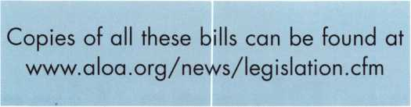

MARYLAND SB 125

Continues the licensing and regulation of security systems technicians in accordance with the provisions of the Maryland Program Evaluation Act (Sunset Law) by extending to July 1, 2016 the termination provisions relat­ing to the statutory and regulatory authority of the Secretary of the State Police to license and regulate security systems technicians.

STATUS: 01/11/2002 Introduced

02/14/2002 Passed Senate 02/15/2002 To HouseCommittee on

Commerce and Government Matters

MARYLANDY HB1004

Clarifies the State Security Systems Technicians Act by including the defini­tion of security system.

STATUS: 02/08/2002 Introduced

03/20/2002 Died in Committee

MINNESOTA HB2787

Relates to public safety; requires that employees and prospective employ­ees of electronic security system companies, certain electrical contractors, and alarm and communication contractors undergo criminal history back­ground checks; provides procedures for these background checks; author­izes the discharge of employees based on the results of the background checks and providing that there is no liability for so doing; provides for license disqualification in certain instances.

STATUS 01/31/2002 Introduced

03/20/2002 From House Committee on

Rules and Legislative Administration:

Do pass as amended 03/21/2002 Passed House

• This bill originally only covered electrical contractors. Amendment added in "electronic security systems" which includes, "burglary detec­tion, access control, or closed circuit television."

MISSISSIPPI SB2482

Relates to the licensing and regulations of installing burglar alarms.

STATUS: 01/18/2002 Introduced

01/18/2002 To Senate Committee on Business and Financial Institutions 02/05/2002 Died in Committee

NEW YORK SB 1859

Provides a possible tax credit in cities of one million or more for security improvement measures or enhancements made in class 2 dwellings; authorizes a one time credit of up to 20% of the cost of such measures or enhancements.

STATUS: 02/11/2002 Introduced

02/12/2002 From Senate Committee on Cities

CHECK OUT ALOA'S WEBSITE AT <http://www.aloa.org/news/legcom.cfm>

FOR THE LATEST HAPPENINGS IN YOUR STATE

**38**

Keynotes • April 2002



OHIO HB452

Creates the Commission on Electronic Security System Regulation in the Department of Commerce. Definition of Electronic Security System includes access control and CCTV.

STATUS: 01/22/2002 House Committee on Commerce and Labor: Heard Sponsor in Committee

01/29/2002 House Committee on Commerce and Labor: Heard Proponents in Committee.

PENNSYLVANIA HB2075

Regulates the licensure of electrical and alarm system contractors. Establishes the Electrical Contractors Licensing Board. Provides for penalties.

STATUS: 10/24/2001 Introduced

10/24/2001 To House Committee on Professional Licensure

SOUTH CAROLINA SB381

To provide for the licensure of locksmith agencies, to require employee registration, to require signed work order forms when opening resi­dences, commercial establishments and motor vehicles, and to provide penalties for certain violations.

STATUS: 02/27/01 Introduced

02/27/01 Referred to Committee on Labor,

Commerce and Industry

**JOIN**

**THE LEGISLATIVE ACTION NETWORK TODAY!**

As we continue to expand our resources and become more competitive in the legislative arena, we need the monetary resources to match our successes. You can help with as little as $24.95 to the Legislative Fund. This is only the minimum that we are asking, and encourage you to give more if you can. Those that contribute will be given a Legislative Action Network Member kit to use in their grass roots efforts. Members who donate $100 or more become Legislative Action Network Council members, and enjoy the following extra benefits:

Discounts on ALOA bookstore items; 10% rebate on all ACE classes; Complimentary Legislative Convention merchandise Join today by contacting Government Affairs Manager Tim McMullen at tim@aloaorg

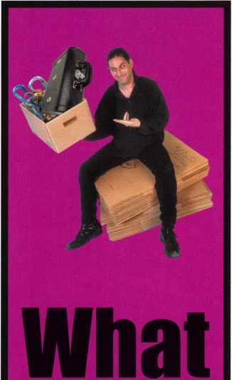

Will

YOU

Find

■i^B

8“ Annual  
Fleamarket?

presented by  
the North Jersey  
Master Locksmiths Association

June 2, 2002  
9am—2pm  
Quality Inn  
Lyndhurst, NJ

Contact: Nick Hart  
(201)944-7547

Or Jeff Sitar  
(973) 777-0620



Keynotes • April 2002

EMPLOYMENT

SECURITY TECHNICIANS NEEDED

Looking for experienced, motivated, hard working technicians and team players. Great income potential. We offer paid holidays, vacation, and medical. Don't delay, fax your resume today. Liberty Lock and Safe, FAX 702/876-5470 or www. I i be rty lock. com.

WANTED: EXPERIENCED PROFESSIONALS

Ready to take a step in the right direction? If you are an experi­enced security professional with strong sales skills, come join our team. We are a rapidly expanding 35-year-old business in the beautiful Pacific Northwest. The ideal candidate would have a strong backgroung in commercial security and door hardware or electronic access control, CCTV and alarms. We will train the right candidate. We offer 401 (k), paid vacation, medical, new uniforms and a work environment that encourages growth and rewards those with dedication! Contact Paul Brandon at The Lock Shop toll free at 866/LOCKSHOP, or on the web at [www.lockguys.com](http://www.lockguys.com).

AUTO EXPERT WANTED

Looking for experienced car/auto locksmith. Great pay, paid vacation, bonus and education. Call 281/830-9441.

EXPERIENCED LOCKSMITHS NEEDED

Servicemen needed for road and shop work in the fields of commercial, residential, automotive, safes, and access control. Pleasant work environment, salary or hourly wages available. Paid vacation, holidays and medical benefits. Fax resumes to

LOCKSMITH POSITION AVAILABLE

Located in beautiful Palm Springs, CA. Valley Lock and Safe has a locksmith position available for someone with at least two years experience. We are a full service locksmith company that specializes in commercial, institutional and residential lock work with some auto work also. We offer competitive salary, uni­forms, and health insurance. We also offer a fully-equipped service vehicle. WE install and service access control systems, CCTV, commercial door hardware and residential door hard­ware. We also install, service and open safes. We offer plenty of training, both in house and off-site. If interested, please con­tact, Craig Smothers, CML, service manager. FAX Resume to: 760/324-7797, or e-mail to: [locknut77@cs.com](mailto:locknut77@cs.com).

SERVICE TECHNICIANS WANTED

Experienced, hard-working service technicians wanted. We offer paid vacation, holidays and medical. Call 781/324- 1600, or fax resumes to 781/321-2422.

STOP LOOKING !!!

Experienced Technicians Wanted. Lock into your future now! If you are the best of the best, we want you! We are a full service commercial/residential security service (locks, keys, safes,

CCTV, access control, intercoms, door related hardware, com­mercial burglar alarms, etc). We offer: sign on bonus, top wages, company vehicle, 401k, paid vacation, paid holidays, new uniforms, cross training, and JOB SATISFACTION.

Bass Security Services, Inc. Ph. 216/755-1200 xl26 Fax 216/755-1220 E-Mail: [rmesnick@bass-security.com](mailto:rmesnick@bass-security.com)

313/563-3617, or call 313/563-6270.

Classified Advertising Policy

Classified advertising space is provided free of charge to ALOA members, and fora fee of $.60 per word, $15 minimum for non-members. Classified ads may be used to advertise  
used merchandise and overstocked items for sale, "wanted to buy" items, business opportunities, employment opportunities/positions wanted and the like. Members or non-members wishing  
to advertise services or new merchandise for sale may purchase a "Commercial Classified Ad," for a fee of $1.30 per word, with a minimum of $40. Each ad will run for two issues. For blind  
boxes there is a $5 charge to members and non-members. All ads must be submitted in writing to the ALOA office by the fifteenth of the month, two months prior to issue date. Send to  
Keynotes Classifieds, 3003 Live Oak St., Dallas TX 75204-6186. ALOA reserves the right to refuse any classified advertisement that it deems inappropriate according to the stated purpose

of the classified advertising section.

J

Keynotes • April 2002



WANTED: SALES PROFESSIONALS

We are seeking experienced, motivated, hard working sales professional­s' join our team. Great income potential! Paid holidays, paid vacations, 401k, and many more benefits. Ideal candidates will have an extensive background in commercial door hardware, access control, CCTV, and the security industry. Only the best of the best need apply.

Bass Security Services, Inc.

Ph. 216/755-1200x126 • Fax 216/755-1220 E-Mail: [rmesnick@bass-security.com](mailto:rmesnick@bass-security.com)

LOCKSMITH SUPERVISOR

Siemens Building Technologies seeks a professional to manage the depart­ment, supervise locksmith staff, maintain master key systems and perform maintenance, installation and troubleshoot repairs on campus buildings. Duties include working on electrical and mechanical locks, adjust latches, duplicate keys, keep inventory, attend meetings, and provide documenta­tion as needed. You will also provide technical support for campus and regional issues. This position is based in Milpitas, CA. The selected candi­date must possess a valid driver's license, excellent communication skills and the ability to read from blueprints and sketches. At least 2-5 years of experience managing a group of field locksmiths is required. Must have computer skills and be organized and detail-oriented. Forward resume to: Attn: SF, 801 Asbury Drive, Buffalo Grove, IL, 60089 Fax 847/403-6405. E-mail: [susan.francq@sbr.siemens.com](mailto:susan.francq@sbr.siemens.com).

Visit us online at [www.sbt.siemens.com](http://www.sbt.siemens.com).

Equal Opportunity Employer M/F/D/V.

BUSINESS FOR SALE

BUSINESS FOR SALE

Well-established lock and safe business for sale in the Midwest. Commercial property is located on the corner of a very busy intersection, has a two-bedroom apartment above shop and a full-service 7-car detached garage in rear. Property appraised for $95,000. Sale includes property, two fully equipped service vans, all fixtures, equipment, and inventory. Gross annual sales of $220,000. Employees will remain; owner available for transition. Owner assisted financing possible.

Call 815/654-0882.

LOCKSMITH OWNER RETIRING

Only locksmith in Montour County (North Central Penn. Area). Includes 24 ft. step van, tools, merchandise, many established accounts, key machines, computer with key codes, all inventory. Shop to be leased if necessary. Over 15 years in the same location. Unlimited potential. Will stay for smooth transition. Call 570/275-3129.

BUSINESS FOR SALE

Well-established locksmith business in S. Central Montana. Good customer base and reputation, good location, low rent. Same location for over 15 years. All inventory, tools, and well-equipped service vehicle (1991 Chevy Astro) included. Great hunting, hiking, camping, and fly fishing in your own backyard! Only 50 miles from Yellowstone National Park. Great opportunity for husband/wife team. Grossing $60K/yr., asking $55K (negotiable). Serious inquiries only. Livingston, MT. Call Steve at 406/2220700.

WANTED TO BUY/SELL

FOR SALE

HPC 1200CM Blitz code machine. Over 100 cards, two cutter wheels, manual and card book. Approximately five years old. Works great.

$1200 plus shipping/insurance. Call John at 203/397-3093, or e-mail at [amitylock@snet.net](mailto:amitylock@snet.net).

FOR SALE

Locksmith magazines published during 1974 to 1998. Keynotes,

Safe & Vault Technology, Locksmith Ledger, Reed's Security Reporter, National Locksmith and others. Also, Beisser key machine, 5-inch cutters, ser #384, Beisser Key Machine Co., Detroit, Mich. Contact Charles Cameron, CML, 336/852-9211 or e-mail: [ccameron@mail.com](mailto:ccameron@mail.com) for complete list and prices.

FOR SALE

Mobile locksmith shop - $4,000. Call 909/927-6858 for details.

Retired ALOA member.

FOR SALE

"24" Segal Jimmy-proof vertical deadbolt locks #666 with model 7050 5-pin cylinders. (Clam-shell packed) MSRP 53.19@ $15. Take all paid by Visa/MasterCard. I will pay shipping in USA. Call W.H. Pulley at 217/824-8696.

FOR SALE

Safe Deposit Box Locks, refurbished HH&M, Diebold, Mosler, KD 73 & KD 76, S&G Miles X-4, Security Corp and more. Large quantities.

Call 954/484-2404 or 888/329-7265.

Keynotes • April 2002

**41**



**Distributor**

ADI Inc

Phone: 516-692-1000 Fax: 516-692-3457

Accredited Lock Supply Co.

Phone: 201-865-5015 Fax: 201-865-0030 [www.acclock.com](http://www.acclock.com)

Ace Lock & Security Supply

Phone: 908-688-7666 Fax: 908-688-2442 [www.acelock.com](http://www.acelock.com)

Action Hardware Inc.

Phone: 800-662-6695 Fax: 800-930-2329

Andrews Wholesale Lock Supply

Phone: 717-272-7422 Fax: 717-274-8659

Boyle & Chase Inc.

Phone: 800-325-2530 Fax: 800-205-3500 [www.boyleandchase.com](http://www.boyleandchase.com)

COMPX Security Products

Phone: 864-297-6655 Fax: 864-297-9987 [www.nclnet.com](http://www.nclnet.com)

Clark Security Products

Phone: 800-854-2088 Fax: 619-974-5284

Cook's Building Specialties

Phone: 505-883-5701 Fax: 505-883-5704

Dire's Lock & Key Company

Phone: 303-294-0176 Fax: 303-294-0198

Direct Security Supply, Inc.

Phone: 800-252-5757 Fax: 800-452-8600

Doyle Security Products

Phone: 800-333-6953 Fax: 612-521-0166 [www.doylesecurity.com](http://www.doylesecurity.com)

Dugmore and Duncan, Inc.

Phone: 888-384-6673 Fax: 888-329-3846

E. L. Reinhardt Co., Inc.

Phone: 800-328-131 1 Fax: 612-481-0166 [www.elreinhardt.com](http://www.elreinhardt.com)

£

Ewert Wholesale Hardware

Phone: 800-451-0200 Fax: 708-597-0881

Fairway Supply, Inc.

Phone: 214-350-0021 Fax: 214-352-4299 [www.fairwaysupply.com](http://www.fairwaysupply.com)

Foley-Belsaw Company

Phone: 800-821-3452 Fax: 816-483-5010 [www.belsaw.com](http://www.belsaw.com)

Fried Brothers Inc.

Phone: 800-523-2924 Fax: 215-592-1255

H L Flake Co.

Phone: 800-231-4105 Fax: 713-926-3399 [www.hlflake.com](http://www.hlflake.com)

H.S. & S. Wholesale Distrib.

Phone: 313-342-6777 Fax: 313-342-7580

Hans Johnsen Company

Phone: 214-879-1550 Fax: 214-879-1530

Hardware Agencies, Ltd.

Phone: 416-462-1921

Howard Keys

Phone: 704-509-4944 Fax: 704-509-6248 www. h owa rd keys .com

IDN Incorporated

Phone: 817-421-5470 Fax: 817-421-5468

Intermountain Lock & Supply

Phone: 800-453-5386 Fax: 801-485-7205 [www.intermountainlock.com](http://www.intermountainlock.com)

Jensen Tools Inc.

Phone: 602-453-3169 Fax: 602-438-1690

Jo Van Distributors

Phone: 416-752-7249 Fax: 416-752-3845

Lockmasters, Inc.

Phone: 859-885-6041 Fax: 859-885-7093 [www.lockmasters.com](http://www.lockmasters.com)

Locks Company

Phone: 800-288-0801 Fax: 305-949-3619

M. Zion Company

Phone: 212-349-8677 Fax: 212-964-0495

Massglass & Door Service

Phone: 888-742-8837 Fax: 818-991-5742 [www.massglass.com](http://www.massglass.com)

McDonald Dash Locksmith Supply

Phone: 800-238-7541 Fax: 901-366-0005 [www.mcdonalddash.com](http://www.mcdonalddash.com)

McManus Locksmith Supply, Inc.

Phone: 704-333-91 12 Fax: 704-332-8664

Monaco Lock Co.

Phone: 800-526-6094 Fax: 800-845-5625 [www.monacolock.com](http://www.monacolock.com)

Omaha Wholesale Hardware

Phone: 800-238-4566 Fax: 402-444-1664 [www.omahawh.com](http://www.omahawh.com)

SecureRite.Com

Phone: 800-241-3930 Fax: 858-974-5269 [www.SecureRite.Corn](http://www.SecureRite.Corn)

Sentry Security Fasteners

Phone: 309-693-2800 Fax: 800-693-2872

Somerset Security Products

Phone: 800-881-5206 Fax: 800-206-9949

Southern Lock and Supply Co.

Phone: 727-541-5536 Fax: 727-544-8278 southernlock.com

Stone & Berg Wholesale

Phone: 800-225-7405 Fax: 800-535-5625

Taylor Security & Lock

Phone: 301-948-7670 Fax: 301-948-1029 [www.taylorsecurity.com](http://www.taylorsecurity.com)

The Locksmith Store Inc.

Phone: 847-364-5111 Fax: 847-364-5125 [www.locksmithstore.com](http://www.locksmithstore.com)

Timemaster Inc.

Phone: 888-798-8465 Fax: 800-798-8463 [www.time-master.com](http://www.time-master.com)

Top Notch Distributors, Inc.

Phone: 800-233-4210 Fax: 800-854-4146 [www.4topnotch.com](http://www.4topnotch.com)

U.S. Lock Corp.

Phone: 800-925-5000 Fax: 800-338-5625 [www.uslock.com](http://www.uslock.com)

Webster Safe & Lock Co., Inc.

Phone: 901-332-2911 Fax: 901-332-2878 webstersinc.com

**Manufacturer**

A & B Safe Corporation

Phone: 800-253-1267 Fax: 856-863-1208 [www.a-bsafecorp.com](http://www.a-bsafecorp.com)

Abloy Door Security

Phone: 800-465-5761 Fax: 514-335-0430 [www.abloy.com](http://www.abloy.com)

Adams Rite Mfg Company

Phone: 800-872-3267 Fax: 800-232-7329 [www.adamsrite.com](http://www.adamsrite.com)

Adesco Safe Mfg. Company

Phone: 800-821-6803 Fax: 562-408-6427 [www.adesco.com](http://www.adesco.com)

Adrian Steel Company

Phone: 800-677-2726 Fax: 517-265-5834 [www.adriansteel.com](http://www.adriansteel.com)

Alarm Lock Systems Inc.

Phone: 800-252-5625 Fax: 516-789-3383 [www.alarmlock.com](http://www.alarmlock.com)

American Lock Company

Phone: 708-534-2000 Fax: 708-534-0531

American Security Products

Phone: 909-685-9680X1083 Fax: 909-685-9685 [www.amsecusa.com](http://www.amsecusa.com)

BWD Automotive

Phone: 334-872-6524 Fax: 334-874-6011 [www.bwdautomotive.com](http://www.bwdautomotive.com)

Baldwin Hardware

Phone: 610-796-4012 Fax: 610-796-4493

Buddy Products

Phone: 800-886-8688 Fax: 312-733-8356 [www.buddyontheweb.com](http://www.buddyontheweb.com)

**2**

Keynotes • April 2002



Curtis Industries,

A Barnes Distribution Company

Phone: 800-555-5397 Fax: 800-867-6020 [www.curtisindustries.com](http://www.curtisindustries.com)

DETEX Corporation

Phone: 800-729-3839 Fax: 830-620-6711

DORMA Architectural Hardware

Phone: 717-336-3881 Fax: 717-336-3500 [www.dorma-usa.com](http://www.dorma-usa.com)

Don-Jo Manufacturing, Inc.

Phone: 978-422-3213 Fax: 978-422-3467 [www.don-jo.com](http://www.don-jo.com)

Door Controls International

Phone: 800-742-3634 Fax: 800-742-0410 [www.doorcontrols.com](http://www.doorcontrols.com)

ESP Lock Products Inc.

Phone: 978-562-3481 Fax: 978-562-9859

HES, Inc.

Phone: 623-582-4626 Fax: 623-582-4641 [www.hesinnovations.com](http://www.hesinnovations.com)

HPC, Inc.

Phone: 847-671-6280 Fax: 847-671-6343 [www.hpcworld.com](http://www.hpcworld.com)

Hongtai Lock Co. Ltd.

Phone: 137-238-1414 Fax: 208-793-3856

INTELLIKEY Corp.

Phone: 800-226-0703 Fax: 321-724-0811 www. i n te11 i key. co m

llco Unican

Phone: 252-446-3321 Fax: 252-446-4702 [www.kaba-ilco.com](http://www.kaba-ilco.com)

Jet Hardware Mfg., Co.

Phone: 718-257-9600 Fax: 718-257-0973

KABA High Security Locks

Phone: 860-621-3601 Fax: 860-621-9727 [www.kabausa.com](http://www.kabausa.com)

KEY-BAK/West Coast Chain Mfg.

Phone: 909-923-7800 Fax: 909-923-0024 [www.keybak.com](http://www.keybak.com)

Knaack Manufacturing Co.

Phone: 800-456-7865 Fax: 815-459-9097 [www.weatherguard.com](http://www.weatherguard.com)

LAB Security

Phone: 800-243-8242 Fax: 860-583-7838 [www.labpins.com](http://www.labpins.com)

LCN Closers/Div of Ingersoll

Phone: 815-875-3311 Fax: 815-879-1497 [www.lcnclosers.com](http://www.lcnclosers.com)

La Gard Inc.

Phone: 310-325-5670 Fax: 310-325-5615 [www.lagard.com](http://www.lagard.com)

Locksmith Ledger International

Phone: 770-886-0800 Fax: 770-889-7703 lledger.com

Lucky Line Products, Inc.

Phone: 858-549-6699 Fax: 858-549-3241

M.A.G. Security

Phone: 714-891-5100 Fax: 714-892-6845 [www.magsecurity.com](http://www.magsecurity.com)

MARKS, U.S.A.

Phone: 516-225-5400 Fax: 516-225-6136 [www.marksusa.com](http://www.marksusa.com)

MARRAY ENTERPRISES

Phone: 408-970-0213 Fax: 408-970-8767 [www.marray.com](http://www.marray.com)

MCS Communication Systems

Phone: 514-444-2040 Fax: 514-444-2029 [www.mcscommunication.com](http://www.mcscommunication.com)

MMD, Inc.

Phone: 865-428-3611 Fax: 865-453-4136

MUL-T-LOCK USA, Inc.

Phone: 800-562-3511 Fax: 973-778-4007 [www.mul-t-lock.com](http://www.mul-t-lock.com)

Master Lock Company

Phone: 414-444-2800 Fax: 414-444-0322 [www.masterlock.com](http://www.masterlock.com)

Medeco Security Locks

Phone: 540-380-5000 Fax: 540-380-5010 [www.medeco.com](http://www.medeco.com)

Meilink Safe Company

Phone: 800-634-5465 Fax: 800-896-6606 [www.fireking.com/products_Meilink/](http://www.fireking.com/products_Meilink/) mk_home.htm

NKL Industries Inc

Phone: 800-528-9900 Fax: 757-485-0271

[www.nklindustries.com/products_NKL/](http://www.nklindustries.com/products_NKL/)

index.htm

ROFU International Corp

Phone: 800-255-7638 Fax: 253-922-1728 [www.rofu.com](http://www.rofu.com)

Rutherford Controls Int'l Co

Phone: 757-427-1230 Fax: 757-427-9549 [www.rutherfordcontrols.com](http://www.rutherfordcontrols.com)

STRATTEC Security Corp.

Phone: 414-247-3333 Fax: 414-247-3329

Sargent & Greenleaf, Inc.

Phone: 606-885-941 1 Fax: 606-885-3063 [www.sglocks.com](http://www.sglocks.com)

Sargent Manufacturing Co

Phone: 203-562-2151 Fax: 203-776-5992

Schlage Lock Co

Phone: 719-264-5300 Fax: 719-264-5382 [www.schlagelock.com](http://www.schlagelock.com)

Schwab Corp

Phone: 765-447-9470 Fax: 765-447-8278 [www.schwabcorp.com](http://www.schwabcorp.com)

Securitron Magnalock Corp.

Phone: 775-355-5626 Fax: 775-355-5636 [www.securitron.com](http://www.securitron.com)

Security Door Controls

Phone: 805-494-0622 Fax: 805-494-8861 [www.sdcsecurity.com](http://www.sdcsecurity.com)

Security Solutions

Phone: 405-376-1600 Fax: 405-376-6870

Sentry Group

Phone: 716-381-4900 Fax: 716-381-8559 [www.sentrysafe.com](http://www.sentrysafe.com)

Sully Tools Inc

Phone: 703-689-3416 Fax: 703-787-0869 [www.sullytools.com](http://www.sullytools.com)

SunSafes Manufacturing Co.

Phone: 823-194-59300 Fax: 823-194-59400 [www.eaglesafes.com](http://www.eaglesafes.com)

Taymor Industries, Inc.

Phone: 800-388-9887 Fax: 800-288-8133

Trine Access Technology

Phone: 718-829-2332 Fax: 718-829-6405 [www.trineonline.com](http://www.trineonline.com)

Videx Inc

Phone: 541-758-0521 Fax: 541-752-5285

W-LOK Corporation

Phone: 616-355-4015 Fax: 616-355-4295 [www.wlokcorp.com](http://www.wlokcorp.com)

Yale Security Group, Inc.

Phone: 800-438-1951 Fax: 800-338 0965

**Service Organization**

Allstate Insurance Company

Phone: 847-402-8196 Fax: 847-326-7509 [www.allstate.com](http://www.allstate.com)

Emergency Road Service Inc

Phone: 888-839-5386 Fax: 678-277-8105

Professional Business Prod­ucts

Phone: 800-258-6219 Fax: 813-888-5393

The National Locksmith

Phone: 630-837-2044 Fax: 630-837-1210 [www.thenationallocksmith.com](http://www.thenationallocksmith.com)

Keynotes • April 2002

**back page**

About the Authors

John Roos is a writer who has been published in several periodicals dealing with government officials and the IRS.

Claire L. Cohen, the second woman to become a CML, has been in locksmithing since 1977 and has been writing articles for Keynotes since 1987. She is also a contributing editor for Keynotes.

Donald B. Dennis, CPL, has been in the locksmithing profession since 1972, and had a four-year apprenticeship in Albuquerque, NM. He founded and has been the owner of Dennis Safe and Lock in Johnson City, TN, since 1977. He was the founder of the East Tennessee Locksmith Association in 1998 and is currently chairman of the Education Committee and editor of the ETLA Newsletter.

Sal Dulcamaro, CML, has been in the security industry for over 26 years. He is the president of All Pro Security, Inc. in Michigan and has been an ALOA member for 19 years. A past president of the

Locksmith Security Association of Michigan, Sal currently serves as web editor of the asso­ciation’s on-line newsletter. He was named Keynotes “Author of the Year” in both 1996 and 1997. He is also a contributing editor for Keynotes. Find Sal on the Internet at: http: //www. home, earthlink. net/~lockwriter.

Greg Perry, CML, CPS has been in the lock­smith industry for 19 years. He’s spent half of that time as a field technician for Security Engineering in Ridgecrest, CA. Greg is also a past president of the Desert Counties Chapter of the California Locksmiths Association.

|  |  |
| --- | --- |
| r |  |
| Ad Index |  |
| Yale Inside Front Cover | |
| STAM Insight | 5 |
| MLANJ 2002 Convention ... | 7 |
| AVIS | ...23 |
| North Jersey  Master Locksmiths Assoc | ...39 |
| Hickok Back Cover | |
| L | J |



Keynotes • April 2002



AL»A

July 22-28, 2002 • Donald E. Stephens Convention Center • Hyatt Regency O'Hare

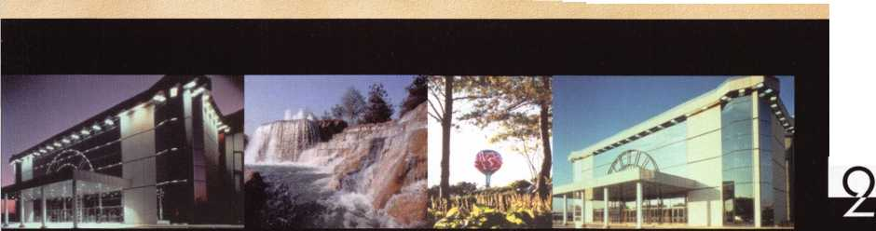

r-i ■

Ifn

I * *

|  |  |  |  |
| --- | --- | --- | --- |
|  | r rJ |  | N \ |
| r-i | P |  |  |
|  |  |  |  |

**Hickok’s New Generation STAR transports you with the factory tool for programming keys to**

**Ford-Lincoln-Mercury and Mazda vehicles with passive anti theft systems (PATS).**

**Program vehicle keys through Model Year 2001 with Hickok’s NGS Model 800-8LA-$1995**

**Update your existing software-the 2001 Complete New Model Ford Software Update Model 80LA-$895**

**800/342-5080**

**HICKOK**

**INCORPORATED**

**uiuiui.hickok-inc.co**

